International Criminal Police Organization (INTERPOL)

U.S. National Central Bureau
(INTERPOL-USNCB)

U.S. Department of Justice (DOJ)

Washington, D.C.

FY 2010 Performance Budget

Congressional Submission

Table of Contents

Overview 1

Summary of Program Changes 7

Decision Unit Justification 8

INTERPOL-United States National Central Bureau (INTERPOL-USNCB)

Program Description

Performance Tables

Performance, Resources, and Strategies

IV. Exhibits

Organizational Chart

Summary of Requirements

Program Increases by Decision Unit

Resources by DOJ Strategic Goal/Objective

Justification for Base Adjustments

Crosswalk of 2008 Availability

Crosswalk of 2009 Availability

Summary of Reimbursable Resources

Detail of Permanent Positions by Category

Financial Analysis of Program Increases

Summary of Requirements by Grade

Summary of Requirements by Object Class

Status of Congressional Requested Studies, Reports and Evaluations (Not

Applicable)

INTERPOL-USNCB FY 2010 Performance Budget

Congressional Submission

I. Overview for the U.S. National Central Bureau of INTERPOL

A. Introduction

In FY 2010, the INTERPOL-USNCB requests a total of $30,091,000, 73 FTE, and 77 positions to prevent crime, enforce federal laws and fight terrorism. This request includes total program increase of $2,216,000, 8 FTE, and 14 positions (none of which are agents or attorneys). Of the program increase, INTERPOL-USNCB is requesting enhancements to our base IT budget for $1,296,000, 1 FTE, and 2 positions to continue with Phase II of our law enforcement information sharing initiative.

With these resources, the INTERPOL-USNCB will be able to increase the number of quality cases related to terrorism, violent crime, drug trafficking, and cyber crime. Electronic copies of the Department of Justice’s Congressional Budget Justifications and Capital Asset Plan and Business Case exhibits can be viewed or downloaded from the Internet using the Internet address: http://www.usdoj.gov/jmd/2010justification

B. Background

Protecting the citizens of our country from threats domestic and abroad is the top priority of the Department of Justice (DOJ). DOJ’s Strategic Plan makes clear that the Department pursues its mission to prevent terrorism and promote the nation’s security through an integrated approach that leverages its law enforcement capabilities across the Department, working with other parts of the federal government and building partnerships with state and local law enforcement and foreign governments. The nature of the threat is a complex one that has led DOJ to develop a multifaceted and integrated approach incorporating sophisticated methods of prevention, investigation, prosecution and incarceration.

INTERPOL-USNCB exemplifies this approach to the Department’s Strategic Goals to Prevent Terrorism and to Prevent Crime and Enforce Federal Laws. INTERPOL-USNCB promulgates and facilitates international law enforcement cooperation by acting as the United States representative to the INTERPOL organization on behalf of the Attorney General. The INTERPOL-USNCB is the point of contact for all INTERPOL matters involving the United States, its more than 18,000 state, local and federal law enforcement officials and the 187 other INTERPOL member countries.
The INTERPOL-USNCB receives and replies to criminal investigative requests, transmits national requests for international cooperation, facilitates requested police action or operations, and collects and shares relevant criminal and investigative information. The INTERPOL-USNCB operates 24 hours a day, 7 days a week each day of the year.

Federal and state law enforcement agencies participate in the INTERPOL-USNCB through detailed personnel. As of February 2009, 30 sworn law enforcement officers from 17 agencies, associated with 10 Departments, Independent Agencies, or State Police forces, augment staffing at the INTERPOL-USNCB. Criminal Investigators, Intelligence Analysts, Inspectors and other subject matter experts are detailed to the INTERPOL-USNCB for a specified period of time (generally 2 years). These personnel operate in divisions dedicated to specific investigative areas, typically with a nexus to their parent agency’s jurisdiction and expertise: Alien/Fugitive, Economic Crimes, Drugs, Terrorism and Violent Crimes, and State and Local Liaison. All of these major areas utilize the services and expertise of analysts to create and maintain the information contained in the INTERPOL-USNCB case files. The analysts help to develop trends and patterns, and establish links and interrelationship in complex criminal cases.

C. Current Issues, Trends and Desired Outcomes

Although the INTERPOL-USNCB’s mission and strategic objectives will not change in FY 2010, three priority items have been identified. These items are driven by the Administration’s continued emphasis on improved information exchange among law enforcement agencies to increase efficiency in government and, most importantly, to prevent acts of violent crime and terrorism against the American people.

INTERPOL-USNCB continues to expand its premier initiative to develop an actionable list of stolen and lost travel documents (for example, identity cards, passports, and visas), to prevent the illicit travel of international terrorists and criminals.

Through the second phase of its information sharing program, the INTERPOL-USNCB continues to provide unprecedented federated access to INTERPOL data using legacy systems that are currently in line with existing law enforcement models.

Project Vennlig successfully provides terrorist information among INTERPOL member countries and the U.S. law enforcement community.

Through the initiatives outlined above, and described in greater detail below, the INTERPOL-USNCB will continue to effectively use its unique position as a member of the world’s only international law enforcement organization to benefit DOJ and the U.S. law enforcement community.

D. Full Program Costs

The INTERPOL-USNCB is one decision unit and all requested funds will support the Department’s Strategic Goal 2, Prevent Crime, Enforce Federal Laws and Represent the Rights and Interests of the American People. This is the strategic goal under which INTERPOL-USNCB was placed as an administrative convenience to comport with the Office of Management and Budget Circular A-11, which calls for the alignment of goals with budget requests in strategic plans. However, INTERPOL-USNCB is a unique organization whose mission cuts across all of the Department’s strategic goals and objectives. While the FY 2010 funding request for INTERPOL-USNCB will support the Department’s Strategic Goal 2, it will also support the following strategic objectives of the Department’s Strategic Goal 1, Prevent Terrorism and Promote the Nation’s Security:

1.1 Prevent, disrupt, and defeat terrorist operations before they occur
1.2 Strengthen partnerships to prevent, deter, and respond to terrorist incidents

The total costs include the following:

1. The direct cost of all outputs for the INTERPOL-USNCB operational expenses, and
2. Indirect costs in the form of the U.S. dues obligation to INTERPOL.

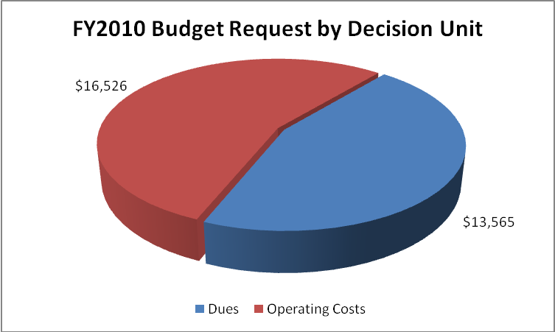

E. Performance Challenges

The increase in transnational crime and the risks associated with international terrorism have resulted in a greater need for international law enforcement cooperation and access to international law enforcement information. The INTERPOL-USNCB’s responsibility to respond to increasing foreign and domestic requests places additional operational demands on the resources of this organization.

- Member countries expansion of INTERPOL databases to border points has led to a significant increase in cases and message traffic across the network.

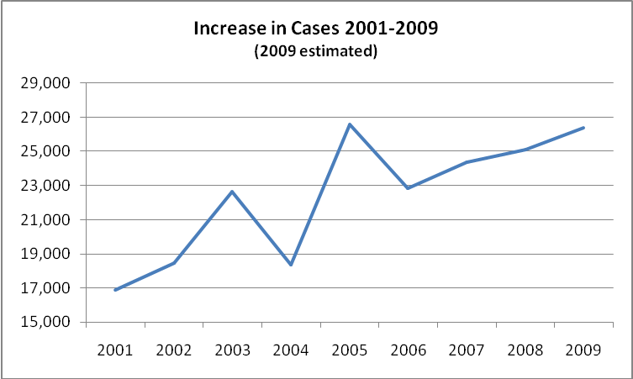

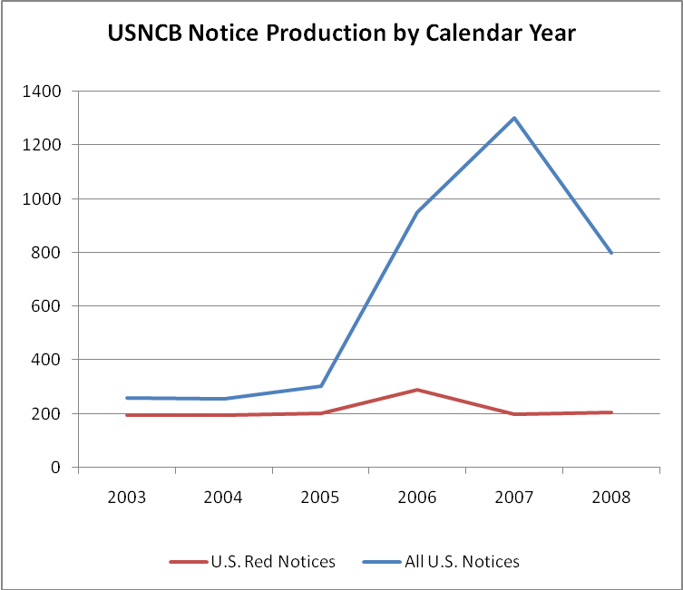

- INTERPOL-USNCB has experienced a reduction of detailed personnel to support its operational divisions, increasing the difficulty of fulfilling its mission.

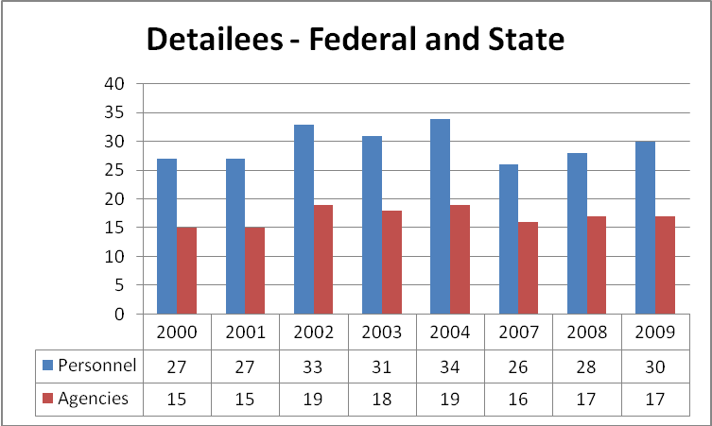
(No data available for 2005-2006)

- INTERPOL-USNCB receives little to no funding from participating agencies for operating expenses for their detailed personnel.
- Enhancing U.S. domestic agencies access to INTERPOL databases involves a number of technical, administrative and legal agreements which are slow to implement

Funding U.S. Dues to the INTERPOL Organization

The INTERPOL General Assembly (IGA), in its September 2001 session, initiated an important policy change affecting member countries and their contributions. The IGA established a new dues structure whereby the six countries with the highest Gross Domestic Product would pay the highest dues. As a result, the United States contribution to INTERPOL increased from 5.56 percent in 2001 to 13.26 percent in 2006. The current proposal provides for an increasing responsibility for the U.S. through 2014.

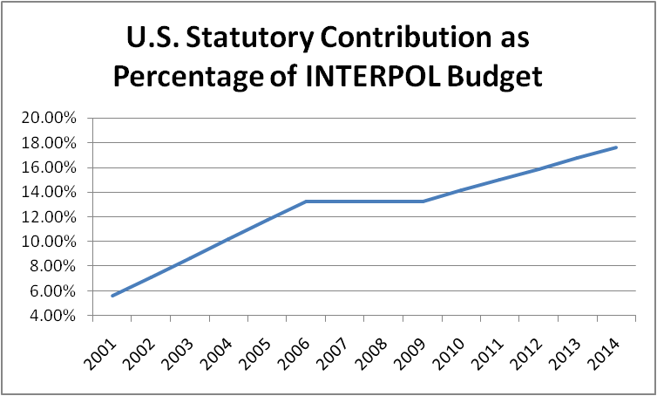

The resulting dues contribution, paid in Euro, has increased from €1.23 million in 2001 to €6.445 million in 2009. The current IGA proposal will raise the INTERPOL-USNCB dues payment to €10.426 million by 2014 assuming the INTERPOL budget increases at an inflationary rate only. However, past experience has led us to believe that the INTERPOL budget will continue to increase above a standard inflationary rate as it has done consistently and substantially primarily due to post-9/11 needs.

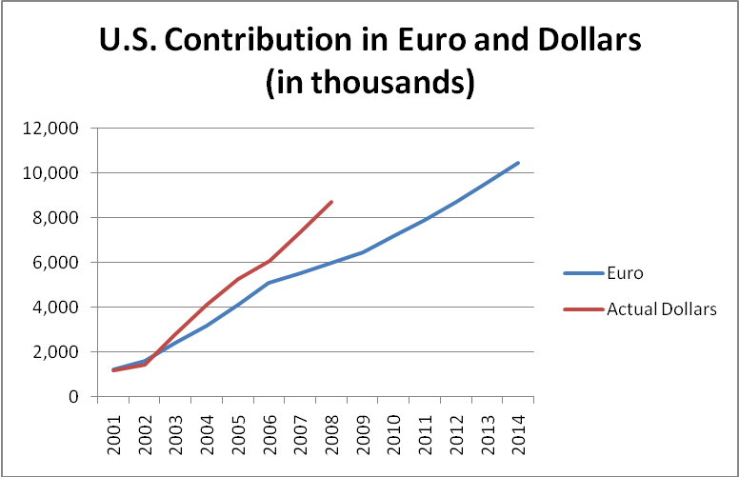

Another uncontrollable factor is the value of the U.S. dollar relative to the Euro. Beginning in 2003, the U.S. dollar’s value relative to the Euro began to decline, resulting in additional dues increases as the dollar “bought” fewer Euro. That decline continued through 2008 and is represented in the following table.

As a result of INTERPOL budget increases, escalating U.S. dues, and the U.S. dollar’s decline in value relative to the Euro, INTERPOL-USNCB’s required financial contribution to INTERPOL has increased significantly leaving INTERPOL-USNCB with less for operations.

II. Summary of Program Changes

Item Name | Description |  |  |  | Page
Item Name |  | Pos. | FTE | Dollars ($000) | Page
Stolen/Lost Travel Document | An actionable list of stolen and lost travel documents (for example, identity cards, passports, and visas), to prevent the illicit travel of international terrorists and criminals | 9 | 5 | 692 | 3
Information Sharing – Phase II | Provides unprecedented federated access to data using legacy systems that are currently in line with existing law enforcement models | 2 | 1 | 1,296 | 18
Project Vennlig | Provides terrorist information among INTERPOL member countries and the U.S. law enforcement community | 3 | 2 | 228 | 28

III. Decision Unit Justification

Key INTERPOL-USNCB budget data for FY 2008-2010 is provided in the tables below:

A. United States National Central Bureau

INTERPOL-USNCB TOTAL | Perm. Pos. | FTE | Amount
2008 Enacted with Rescissions | 63 | 65 | 23,252
2008 Supplemental | 0 | 0 | 0
2008 Enacted w/Rescissions and Supplemental | 63 | 65 | 23,252
2009 Enacted | 63 | 65 | 24,548
Adjustments to Base and Technical Adjustments | 0 | 0 | 3,327
2010 Current Services | 63 | 65 | 27,875
2010 Program Increases | 14 | 8 | 2,216
2010 Request | 77 | 73 | 30,091
Total Change 2009-2010 | 14 | 8 | 5,543

1. Program Description

The U.S. National Central Bureau facilitates international law enforcement cooperation by serving as a police-to-police communications and intelligence network for both American and foreign police seeking assistance in criminal investigations. The INTERPOL-USNCB brings together international and U.S. police at federal, state, local, municipal, and tribal levels, providing a neutral territory where jurisdictions and mandates are interwoven to permit cooperation and assistance in combating international crime. INTERPOL-USNCB initiates and responds to criminal investigative requests; transmits national requests for international cooperation; facilitates requested police action or operations; and collects, analyzes, and shares relevant criminal intelligence.

3. Performance, Resources, and Strategies

a. Performance Plan and Report Outcomes

In support of DOJ’s Strategic Goal 2, Enforce Federal Criminal Laws, the INTERPOL-USNCB will carry out its representational role for the Attorney General by executing the following functions:

- Coordinate arrangements for payment of the mandatory INTERPOL member dues;
- Communicate and exchange information between international and domestic law enforcement agencies;
- Ensure that the common interests of the United States are represented to the international law enforcement community;
- Delineate trends and patterns in international criminal activity;
- Provide leadership and expertise at global law enforcement symposia, conferences and meetings.
- Ensure access to INTERPOL data for U.S. federal, state, local, tribal and municipal law enforcement.

Furthermore, the INTERPOL-USNCB will continue to facilitate cooperation among foreign and domestic law enforcement by making it easier to obtain information and evidence needed to pursue fugitives and track criminal activity. The INTERPOL Notice and Diffusion program, working jointly with foreign counterparts, is a realistic way to achieve the goals of dismantling international criminal organizations, locating fugitives, and establishing mutually-recognized processes to ensure that fugitives are brought to justice.

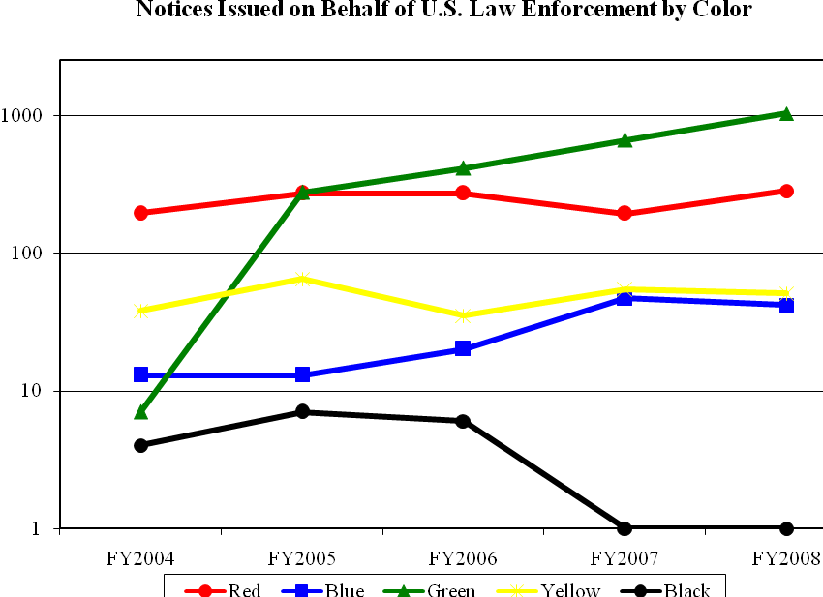
Data Definition: each INTERPOL color-coded notice has a specific purpose:

Red - to request the arrest or detention of a wanted person
Blue - to trace and locate a suspect or witness
Green - to provide information on a known/convicted criminal
Yellow - to request the location of a missing child or adult
Black - to identify an unidentified body

Data Collection and Storage: The data source for the number of INTERPOL notices issued is the INTERPOL General Secretariat and the INTERPOL-USNCB case management system (‘ENVOY’).

Data Validation: INTERPOL Notice data is reviewed and approved by the INTERPOL-USNCB Compliance Officer.

Data Limitations: None known at this time.

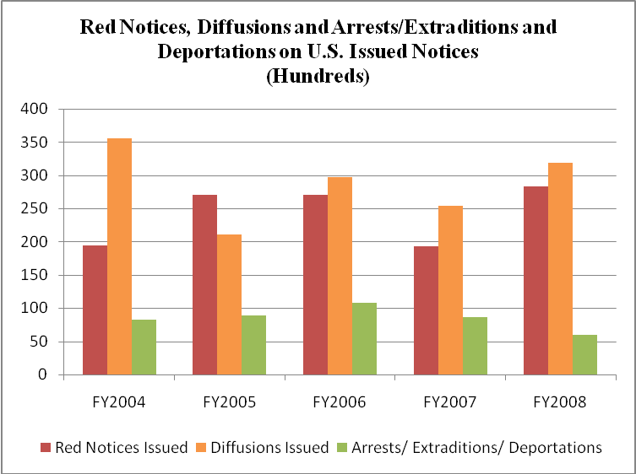
Data Definition: Red Notice – international request to arrest/detain wanted person

Diffusion – international ‘be on the lookout’ message (precursor to red notice)

Arrest/Extradition/Deportation – positive outcome of an INTERPOL notice or diffusion

Data Collection and Storage: The data source for the number of INTERPOL notices issued is the INTERPOL General Secretariat and the INTERPOL-USNCB case management system (‘ENVOY’).

Data Validation: INTERPOL Notice data is reviewed and approved by the INTERPOL-USNCB Compliance Officer.

Data Limitations: Outcome not reliably reported to INTERPOL-USNCB, resulting in underreporting of total number of arrests/extraditions/deportations.

b. Strategies to Accomplish Outcomes

The INTERPOL-USNCB has formed strategic partnerships with U.S. law enforcement agencies that have assigned agents to the INTERPOL-USNCB to initiate and respond to international inquiries. The INTERPOL-USNCB further participates in such international law enforcement initiatives as: Fusion Task Force (provides link analysis on terrorist groups and individuals); Millennium Project (Eastern European Organized Crime); Project Rockers (International Outlaw Motorcycle Gangs); Project Bridge (human trafficking); International Stolen Vehicle Programs, International Stolen/Lost Travel Documents Program and the INTERPOL Bioterrorism Program. The Notice and Diffusion program builds the capacity to rapidly identify and arrest known and internationally wanted individuals leading to their eventual extradition, deportation and/or prosecution.

The INTERPOL-USNCB will also continue to use its expertise to assist in halting international parental abductions in progress, pursue child abductors, and locate victim children.

Through INTERPOL, every law enforcement agency in the United States can contact police, customs, and immigration authorities in 186 other member countries. The anticipated outcome is the reduction of crime domestically and internationally.

Program Increases

Item Name: INTERPOL Stolen and Lost Travel Document Program
Budget Decision Unit(s): United States National Central Bureau
Strategic Goal(s) & Objective(s): Goal 2, Strategic Objectives 2.2 & 2.3
Organizational Program: Alien and Fugitive Division

Program Increase: Positions _ 9 _ Agt/Atty____ FTE __5 _ Dollars _$ 692,000_

Description of Item

INTERPOL-USNCB requests nine (9) full-time positions to support its INTERPOL Stolen Lost Travel Document Database program (SLTD).

SLTD is an actionable list of stolen/lost travel documents (e.g., identity cards, passports and visas) administered by INTERPOL to prevent the illicit travel of international terrorists and criminals. The database currently contains over 17 million records, including approximately 9 million passports, populated by 146 INTERPOL member countries and the United Nations. INTERPOL makes the system available to police and border security authorities in 187 INTERPOL member countries, through its respective National Central Bureaus (NCBs). The INTERPOL-USNCB is the primary focal point for US participation in the SLTD program. This includes ensuring the timely and accurate reporting of stolen/lost US passport data to INTERPOL; establishing and maintaining query access by US law enforcement and border inspection authorities; performing ‘hit’ verification and resolution for cases involving positive SLTD searches on foreign passports presented at US border points; and working with foreign counterparts to resolve cases involving lost/stolen fraudulent US passports which are the subject of SLTD hits at foreign border points.

The INTERPOL-USNCB FY2010 budget submission requests eight (8) INTERPOL Analyst (GS-12) positions to support SLTD operations at INTERPOL-USNCB, and one (1) Program Manager (GS-13) to oversee and coordinate program activities. This figure is based on staffing requirements formulated in Appendix 1.

Justification

US participation is considered critical to the success of this international program. In May 2007, Congress and the Departments of Homeland Security and State formally recognized the importance of greater use of the system as a screening tool at US ports of entry. International organizations such as the G8, the European Union, the Organization for Security and Co-operation in Europe and the United Nations’ Security Council have also endorsed the program. Presently all countries participating in the US Visa Waiver Program report their stolen/lost passport data to the INTERPOL SLTD, as set forth in the Implementing Recommendations for the 9/11 Commission Act of 2007, Pub. L. No. 110-53.

The United States is currently the number one contributor of information on lost/stolen passports to the INTERPOL SLTD database, with over 1.6 million records updated on a daily basis. The INTERPOL-USNCB ensures the regular transfer of US lost/stolen passport data to the INTERPOL database, and leads an inter-agency working group on the legal and procedural issues related to its use. INTERPOL-USNCB also coordinates SLTD hits on US lost/stolen passports with the appropriate US authorities to confirm the credentials of the individual presenting the document, identify any criminal intent, and coordinate subsequent law enforcement action to be taken, as necessary. Queries by INTERPOL member countries to the SLTD database have steadily increased over the past year. As of February 2009, Brazil, Chile, France, Norway, Oman, Switzerland, and the United Kingdom, were among the INTERPOL members to have expanded SLTD access beyond their NCBs to national border points and police agencies, significantly increasing the volume of SLTD hits on US passports and follow-up required by INTERPOL-USNCB.

In 2008, the INTERPOL-USNCB enabled use of the SLTD by DHS US Customs & Border Protection (CBP) for routine queries against the system at all US air and seaports. By June 1, 2008, INTERPOL-USNCB and CBP had activated SLTD checks for all international travelers entering the United States by air. This was accomplished by establishing an interface between SLTD and the Advance Passenger Information System (APIS) administered by CBP. By January 2009, CBP had activated the SLTD-APIS interface at all US seaports. As a result, the total number of US searches against the database tripled from January to December 2008, and the total number of new SLTD cases handled by INTERPOL-USNCB more than doubled. During the 2008 calendar year, the United States generated nearly 4.2 million searches against the database, resulting in 4,890 positive hits and involving stolen/lost documents from 77 different countries.

Figure 1: US SLTD Usage Statistics for 2008

In 2008, SLTD-APIS hits at US borders represented the largest percentage of new incoming requests for assistance processed at INTERPOL-USNCB, comprising 95% percent of all incoming requests from CBP.
Figure 2: INTERPOL-USNCB Federal Incoming Requests for Assistance

In 2009, with the proper support, the INTERPOL-USNCB plans to expand SLTD connectivity to US land borders and Consular offices abroad. The growth of the SLTD database and the expansion of the INTERPOL-USNCB network will require additional resources at INTERPOL-USNCB to successfully manage the program.

If funded, duties for the requested positions will include: responding to incoming inquiries regarding hits on US SLTD data; assisting with hit confirmation; coordinating US SLTD activity among DOS and CBP authorities; disseminating information about stolen travel documents within the US law enforcement community; tracking program statistics; reporting program activities; and performing liaison with participating US agencies, INTERPOL’s General Secretariat and foreign counterparts.

In addition to enabling routine SLTD checks at US ports of entry, the INTERPOL-USNCB is currently expanding direct query-access to INTERPOL databases, including the SLTD, for US federal, state and local law enforcement agencies. Several DHS components, including the CBP’s National Targeting Center, the US-Visit Biometric Support Center, and the Immigration and Customs Enforcement’s Customs Enforcement Unit, have already been connected, as well as major US metropolitan police departments and state INTERPOL Liaison Offices. This increased usage of the system, and the requirement for follow-up, has already tripled the number of investigative cases generated by SLTD hits against US records. Furthermore, INTERPOL-USNCB is presently in discussion DOS’ Visa Office, to enable SLTD connectivity at Consular Offices for visa adjudication purposes. Any hits generated by US law enforcement users are routed back to INTERPOL-USNCB for follow-up and resolution. Such usage will only increase as INTERPOL-USNCB seeks to further expand access to NLETS and NCIC users. The INTERPOL-USNCB’s outreach plan is consistent with DOJ’s Global Justice Information Sharing (‘One DOJ’) and DHS’s Law Enforcement Information Sharing initiatives.

Impact on Performance (Relationship of Increase to Strategic Goals)

Support of this program will ensure the INTERPOL-USNCB’s ability to coordinate with US law enforcement and INTERPOL counterparts investigating the use of lost/stolen US and foreign passports and visas. If properly funded this program will lead to increased sharing of lost/stolen passport data among INTERPOL member countries resulting in an increase in the investigation and apprehension of criminals and terrorists who seek to use fraudulently obtained travel documents to carry out their illegal activities.

This program relates directly to the Department’s strategic goals by attacking the infrastructure by which terrorists travel internationally by targeting smuggling organizations and strengthening worldwide enforcement mechanisms" (Goal 1; Strategic Objective 1.1); and by preventing violent crime in the United States by reducing international violent crime." (Goal 2, Strategic Objective 2.2).

Appendix 1: Calculation for SLTD Staffing Requirement
8736 hours in one year = 24/7 coverage

Average FTE works 2080 hours in one year

less

Ten paid holidays = 80 hours

Ten training days = 80 hours

4 weeks vacation = 160 hours

EQUALS a total of 1760 hours to work

8736 divided by 1760 = 5 Full-time staff needed to staff position for 24/7 operations.

PLUS - to cover gaps created by leave and vacation of 320 hrs per person

320 x 5= 1600 hrs coverage needed

1 person needed per shift for a total of three (3) additional people

8 total staff 24/7 plus one Program Manager.

Total staffing needs to operate and manage SLTD Program = 9 FTEs.
Funding

Base Funding

FY2008 Enacted (w/resc/supps) |  |  |  | FY2009 Enacted |  |  |  | FY2010 Current Services
Pos | Agt/Atty | FTE | $(000) | Pos | Agt/Atty | FTE | $(000) | Pos | Agt/Atty | FTE | $(000)
6 | 0 | 6 | 2,164 | 6 | 0 | 6 | 2,284 | 6 | 0 | 6 | 2,413

Personnel Increase Cost Summary

Type of Position | Modular Cost  per Position ($000) | Number of  Positions  Requested | FY 2010  Request ($000) | FY 2011  Net Annualization  (change from 2009)  ($000)
INTERPOL Analyst  GS-301-12 | 76 | 8 | 608 | 520
INTERPOL Program Manager  GS-301-13 | 84 | 1 | 84 | 50
Total Personnel |  | 9 | 692 | 195

Non-Personnel Increase Cost Summary

Non-Personnel Item | Unit Cost | Quantity | FY 2010 Request  ($000) | FY 2011 Net  Annualization  (Change from 2009)  ($000)
Total Non-Personnel

Total Request for this Item

 | Pos | Agt/Atty | FTE | Personnel  ($000) | Non-Personnel  ($000) | Total  ($000)
Current Services | 6 |  | 6 | 614 | 1,799 | 2,413
Increases | 9 |  | 5 | 692 | 0 | 692
Grand Total | 15 |  | 11 | 1,306 | 1,799 | 3,105

Item Name: Law Enforcement Information Sharing Phase II

Budget Decision Unit(s): United States National Central Bureau
Strategic Goal(s) & Objective(s): Goal 2; Objectve.2.2
Organizational Program: Law Enforcement Information Sharing

Program Increase: Positions 2 Agt/Atty 0 FTE 1__ Dollars $1,296,000

Description of Item

The INTERPOL-USNCB proposes continuation of its ongoing Law Enforcement Information Sharing initiatives. Through this project, INTERPOL-USNCB has designed tools to provide access to INTERPOL services to assist domestic law enforcement organizations in their daily operational duties. The INTERPOL-USNCB’s technical approach is to streamline INTERPOL access. Access to these expanded systems will include the ability to exchange biometric data internationally and in real-time. INTERPOL access helps enhance our domestic security and ultimately strengthens law enforcement efforts to protect the United States from international criminals and terrorists that attempt to seek refuge within our borders. This solution by design will be flexible enough to provide metrics for gauging usage to better shape the types of services that we will provide. Establishing and expanding an INTERPOL gateway allows existing domestic law enforcement systems to seamlessly interface with international systems for the first time.

Delivering these services enhances the INTERPOL-USNCB’s role as the central point of contact for INTERPOL related investigations within the United States. Brokering these connections allows the INTERPOL-USNCB to provide a common and centralized solution for auditing and controlling INTERPOL transactions. This also allows the INTERPOL-USNCB to better utilize its internal workforce by responding to international inquiries in the event of positive matches. In the event of a hit, the INTERPOL-USNCB’s 24/7 INTERPOL Operations and Command Center (IOCC) stands ready to assist in the vetting and support of law enforcement officers. Our approach is not defined exclusively by designing new applications but rather by delivering the appropriate level of resources to the end user. Leveraging or allowing domestic agencies to re-use existing applications saves valuable tax dollars and allows INTERPOL data to be accessed by systems that are currently in-line with existing business models.

The first step is the continuation of Phase I Law Enforcement sharing. This phase expands on the ability to deliver INTERPOL data to the U.S. law enforcement community. This expansion is being accomplished in two approaches: 1) leveraging secure networks that are currently in place and 2) establishing secure encrypted connections where none exist, utilizing Internet based technologies. This expansion has included the use of the following existing systems/architectures: FBI’s Law Enforcement Online, National Crime Information Center (NCIC) and the Integrated Automated Fingerprint Information System (IAFIS). Also being leveraged are the National Law Enforcement Telecommunications System (NLETS), the Regional Information Sharing System (RISS) and all OneDOJ sites. Lastly, the INTERPOL-USNCB is working closely with the Department of Justice’s OneDOJ applications and the DHS Law Enforcement Information Sharing systems which play a critical role in delivering INTERPOL data to critical stakeholders around the United States. The INTERPOL-USNCB is continuing to take preliminary steps to enhance its information sharing initiatives, which can be summarized through four of the following technical approaches:

- INTERPOL-USNCB-Secure Net, a continuation of INTERPOL connectivity initiatives for major U.S. metropolitan police departments and airports and seaports through Virtual Private Networks (VPNs) and web-based encryption methods.
  - Goal
    - Provide a semi-meshed network that will allow the various federal, state and local agencies to share and collaborate using secure encrypted connections across the Internet. The Internet is fully meshed, resilient and pervasive.
  - Objective
    - Low cost solution that will continue to expand and provide access to international databases.
    - INTERPOL-USNCB/DOJ managed devices for end-to-end security.
    - For the first time, expand current secure network for exchanging integrated communication and information between major metropolitan systems, no re-tooling of legacy systems required.
    - For 2010, the INTERPOL-USNCB is requesting $76,000 for an Information Technology Specialist (GS-12) to support this expansion initiative to assist with extended deployment and customer support.
  - Cost ($285,000)

- The INTERPOL-USNCB will leverage the use of this secure infrastructure by developing its own gateways to INTERPOL and international systems. By utilizing and deploying its own web service, domestic users will efficiently exchange information with the INTERPOL-USNCB. Any web service interface will be designed to meet exchange standards defined by the National Information Exchange Model (NIEM). End users will have the capability to submit workflow items directly into the INTERPOL-USNCB’s case management system through the use of such a service. By utilizing structured forms, data will be seamlessly tagged, queried and recorded into its case management system. This will eliminate the need for repetitive data entry processes. By submitting data in a structured format, such as XML, better opportunities will be available for running intelligent and accurate queries and reports. Additionally, web services technology will allow domestic law enforcement users to integrate their own applications for querying both INTERPOL and INTERPOL-USNCB systems. For clients that do not have the resources or utilize applications that do not support a web service, a secure encrypted intranet web portal will be provided. The web portal will provide access to a pointer index to INTERPOL-USNCB and INTERPOL data utilizing a federated query and also access to a library of web-based forms to be submitted directly to the INTERPOL-USNCB. The pointer index will not allow direct access to the INTERPOL-USNCB database but to a carefully filtered replica. The benefit in using a federated query is two-fold:

  - The INTERPOL-USNCB data is unique in that it represents data collected from domestic and international data sources.
  - The INTERPOL data will provide results from information submitted by the INTERPOL community at large.

Leveraging query responses from both systems will allow domestic agencies to more thoroughly identify possible leads related to international investigations. All hits will be generated and forwarded to the INTERPOL-USNCB’s 24/7 IOCC. The INTERPOL-USNCB’s strategy will be to deliver access via a web client and to publish an accessible web service to better serve the diverse law enforcement community.
- Goal
    - The INTERPOL-USNCB would begin the process of sharing a subset of its data, developing an INTERPOL-USNCB pointer index.
    - Develop an INTERPOL-USNCB web service to transparently exchange data and biometric information between external law enforcement systems.
      - Allow end users to re-use their respective internal business specific applications.
      - Provide direct interfaces to NCIC for Federated search queries against INTERPOL Data sources.
      - Develop capabilities to receive and process federated IAFIS transactions for real-time checks against the INTERPOL fingerprint systems.
        - In 2008 INTERPOL-USNCB deployed an AFIS terminal that manually converts INTERPOL and IAFIS fingerprint transactions. Our follow-on provides an automated mechanism for this process to occur.

    - Develop web portal for accessing both INTERPOL-USNCB and INTERPOL data utilizing a federated query.
      - Develop interoperability with mobile devices.
      - Develop real-time capture of all INTERPOL-USNCB statistics.
      - Deliver restructured XML forms for direct submission into the INTERPOL-USNCB’s case management system.
      - Provide immediate tracking information to all end users on status of request in real time.
      - Provide direct capabilities of submitting one off INTERPOL Fingerprint checks.
      - Deliver access using Internet based solutions.
        - SSL encryption using signed certificates.
        - Direct Peer to Peer Internet based VPN connections for scalable enterprise access.
    - For 2010, the INTERPOL-USNCB is requesting $76,000 for an Information Technology Specialist (GS-12) to support this initiative.
- Objective
    - Web service will be built using the NIEM data exchange model consistent with DOJ and DHS information sharing initiatives.
- Cost (399,000).

- Develop Single Sign-on Solutions for extended transparency between end user applications and access to INTERPOL and INTERPOL-USNCB databases.
  - Goal
    - Allowing users with the ability to sign in once with a federated ID.
    - Expansion and enhancement of the INTERPOL-USNCB national proxy architecture.
  - Objective
    - Provide the capability of integrating INTERPOL-USNCB specific queries into external systems by minimizing additional log on requirements. The closer the INTERPOL-USNCB can extend its services into the normal operating procedures without requiring a second logon, the more pervasive its use will become making access “second nature”.
    - Leverage the exchanging security associations from trusted external systems for a federated ID.
      - Better integration into pre-existing applications such as:
        - FBI’s Law Enforcement Online
        - Regional Information Sharing Systems (RISS)
        - One DOJ sites
    - Expand the use of the INTERPOL-USNCB’s National Proxy for delivering access to various INTERPOL and INTERPOL-USNCB systems.
  - Cost ($205,000).

- The INTERPOL-USNCB deployed the International Query to NLETS users in 2007. It is the goal to expand access and encouraging data sharing through the National Law Enforcement Telecommunications System (NLETS).
  - Goal
    - Sharing and providing limited access to regional systems in the United States to various selected countries within the INTERPOL community. This type of real time access is the key to stopping and preventing terrorists on an international level.
      - Bidirectional data sharing with state/local and federal law enforcement on an international scale with trusted INTERPOL member countries.
    - Expand the current services being offered to NLETS customers and explore additional opportunities for batch automated transactions such as license plate readers or customs border points.
    - Provide and educate current users on accessing and using the NLETS International Query.
    - Develop NLETS XML forms for INTERPOL-USNCB related inquiries.
    - Design greater resiliency into the NLETS architecture.
      - Establishment of an INTERPOL-USNCB Disaster Recovery Site for greater system availability.
  - Objective
    - Begin discussions concerning accessing additional international and domestic systems using the NLETS architecture.
    - Support full scale automated system queries.
    - Continue education efforts on INTERPOL and the services it can provide the local federal and state NLETS user.
    - Design XML NLETS structured forms for better integration into INTERPOL-USNCB Systems.
      - International Humanitarian Requests
      - International Criminal Record Checks
      - International Criminal Investigations
      - International Notice Applications
      - Automatic Pre-canned Quick Turnaround messages for American Territories
      - Automated status responses for all inquiries submitted via the NLETS system with corresponding ticket number for real time follow-up information.
    - Structured NLETS XML forms eliminate repetitive data entry and reduce the amount of time needed to respond to inquiries.
      - Automatic indexing and querying of INTERPOL-USNCB systems.
      - Full accounting of various requests and turnaround times.
      - Improved metrics to properly gauge agency performance.
  - Cost ($255,000)

Justification

The INTERPOL-USNCB plays a unique role in the fight against international crime and terrorism. As the central point of contact for all International criminal investigations the INTERPOL-USNCB has embarked on an aggressive strategy for providing integrated access to INTERPOL systems. This strategy ensures real-time access to law enforcement officers in the field at minimal cost. It is the goal of the INTERPOL-USNCB to expand access to INTERPOL systems throughout the United States. The INTERPOL-USNCB will reuse existing and funded law enforcement networks and systems. The technical approach is to provide unprecedented federated access to data using legacy systems that are currently in line with existing law enforcement business models. In order to achieve this ambitious goal a national architecture must be put in place in order to support enterprise level services available 24 hours a day, 7 days a week. This approach entrenches the INTERPOL-USNCB as the broker between international and domestic data systems and network. This position allows our staff to provide nationwide services to all law enforcement throughout the United States for matters involving international crime. Further the INTERPOL-USNCB’s approach provides a security layer that safeguards national systems with the INTERPOL-USNCB providing and controlling full auditing and control capabilities. To further INTERPOL access, the INTERPOL-USNCB proposes three strategies for enhancing and expanding access.

The INTERPOL-USNCB over the last year has begun the process of exchanging and providing access to INTERPOL systems throughout the United States. This project has witnessed a certain degree of success with NLETS where real-time access to INTERPOL systems is now available. Further interfaces with the DHS’ APIS and the Electronic Screening Travel Application (ESTA) currently query the INTERPOL database for lost and stolen passport data instantaneously. This prescreening allows DHS to pre-clear travelers (based on passport numbers) on any inbound international flight destined to the United States. Further the INTERPOL-USNCB has developed and implemented an Automated Integrated Fingerprint System (AFIS) that has the ability to convert and check both FBI’s IAFIS and the INTERPOL Fingerprint database. Since the development of this AFIS system the INTERPOL-USNCB is daily submitting INTERPOL prints to the FBI IAFIS system for all INTERPOL Red, Blue and Green notices including prints provided as a result of international diffusions. Providing this service allows all domestic law enforcement to have access to INTERPOL biometric data as it is published for the first time.

But we must not stop here, doing so places our borders and our citizens at risk. Expanding access and ensuring interoperability with international systems enhances our security infrastructure. Our goal is to provide INTERPOL access to every U.S. border point and to make international biometric data available to every law enforcement agency that has been entrusted with protecting the citizens of the United States. Again this is done by developing alliances and re-using systems that are in place and operational. Our technical approach is to provide the gateways that are needed to access these systems and provide the level of control and security needed to guarantee the integrity of our domestic systems. INTERPOL-USNCB must forge past the days of stove pipe insular systems and architectures that do not afford the flexibility or access to external international data. Only by linking such systems does the United States have the capability of defending its borders and identifying threats before they occur. In the last 3 years the INTERPOL-USNCB has demonstrated how successful these projects can be. This can be illustrated in Figure 1 where in 2005 only 651 subjects were recorded by the U.S. in INTERPOL systems. Since 2005 the INTERPOL-USNCB has expanded this number to 1899. In addition the INTERPOL-USNCB expanded access through NLETS and designed internal batch processing utilities. These queries are represented in Figure 2. The INTERPOL-USNCB’s partnership with DHS has resulted in the integration of its APIS and ESTA systems and has led to an unprecedented rise in the use of INTERPOL systems. In 2008, 41 million checks were conducted (represented in Figure 3). Lastly INTERPOL-USNCB’s biometric exchange program processes 20-30 prints a day and adds them to IAFIS with biographic data and photos added to further aid in the identification of known and wanted international criminals. As we improve access it is necessary that these systems stay available. So in conjunction with expanding services the INTERPOL-USNCB is also planning and developing a national architecture that provides not only system redundancy but also geographic redundancy to guarantee continued national access.

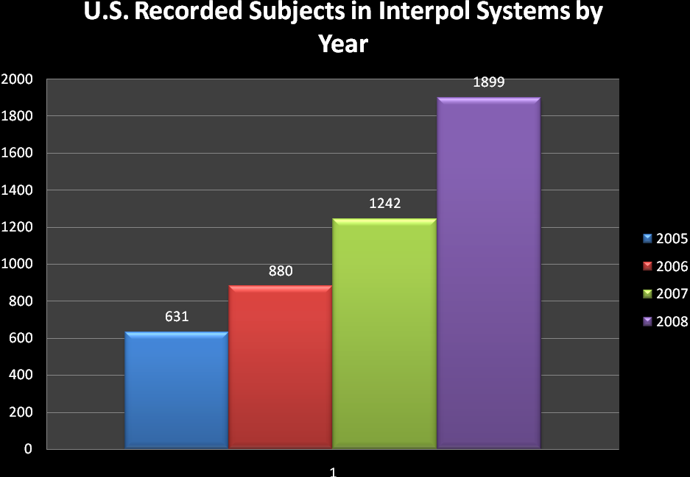
Figure 1
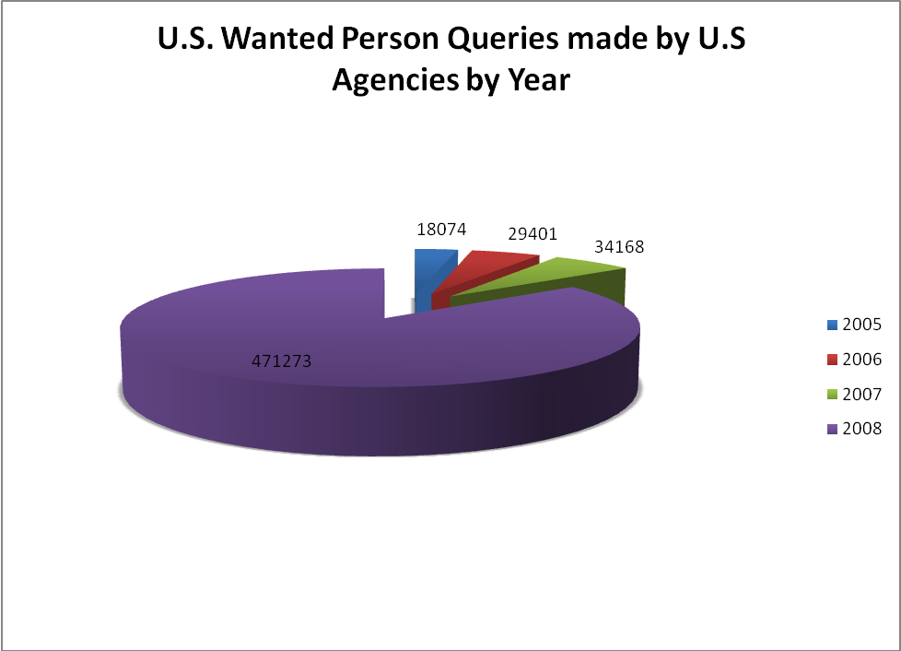
Figure 2

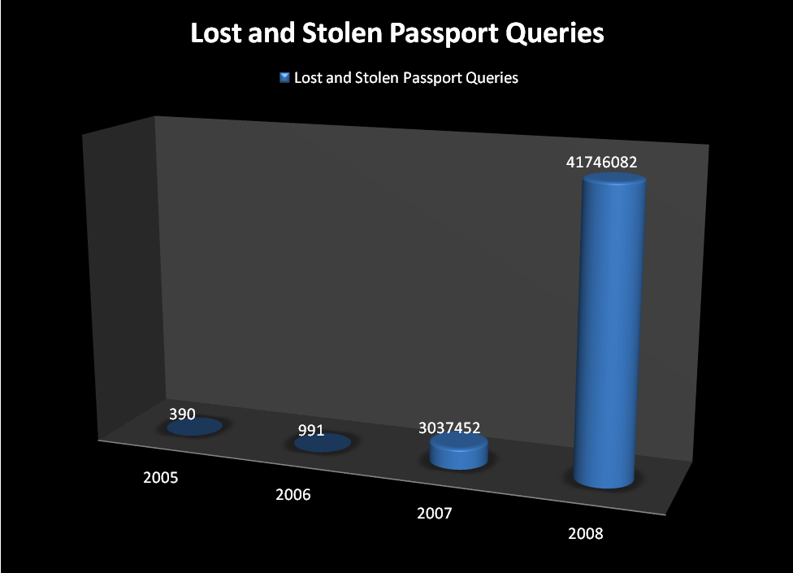
Figure 3

Connectivity Project Details:

- Phase II INTERPOL-USNCB Secure-Net (site-to-site INTERPOL connectivity for U.S. metropolitan police departments through Virtual Private Networks) ($285,000)
  - Connect remaining Metropolitan area networks.
  - Enable secure bi-directional communications between state and local liaison offices.
  - Provide real-time virus scanning of all email with the INTERPOL-USNCB Secure-Net architecture at point of origin.
  - Provide technical guidance on bringing remaining city-wide networks online with the INTERPOL-USNCB secure net architecture.
  - Complete telecommunications foundation for leveraging additional communication sharing initiatives between the domestic and international law enforcement community, all of which will ride off of the INTERPOL-USNCB Secure-Net architecture.
  - Add additional forensic intrusion prevention sensors for detecting anomalies for added security.
  - Add additional network monitoring tools for maintaining 24/7 availability nationwide.

- U.S. National Central Bureau’s International Gateway and ($399,000) Pointer index of all Domestic and INTERPOL communications and investigations
  - Deploy front end database with pointer and catalog information concerning domestic INTERPOL requests.
  - Develop web service to enable end user to connect using legacy systems for the exchange of structured data and the exchange and conversion of Biometric Information.
    - Direct Interface with FBI’s IAFIS
    - Direct Interface with FBI’s NCIC
    - Direct Interface with the Department of State for real-time exchange of Passport information with INTERPOL Systems
    - Design and implementation of a National Architecture for full time
  - Continue development of standardized XML forms for all messages forms and notices.
    - Publish XML schemas in line with the National Information Exchange data model.
  - Develop tools to measure usage, i.e. queries executed, hits generated based on location and agency type. Provide national statistics that for the first time will measure usage of international systems by the domestic law enforcement community.
  - First ever repository available to U.S. law enforcement that allows access to both domestic and INTERPOL related investigations.
  - Positive enquiries will generate Alarms that will be delivered to the INTERPOL-USNCB’s 24/7 IOCC. Only pointer information will be provided on initial hits.
  - Complete audit of all transactions.

- Continued development of a National Proxy providing Single Sign on access to Law Enforcement Personnel ($205,000)
  - Expand current proxy architecture to provide transparency between end user applications and international systems.
  - Federated identity to multiple international systems based on a shared set of user security attributes.
    - Define Security Authorization Markup Language (SAML) assertions for further integration into regional systems. Access will based on common criteria shared among the various trusted systems, eliminates duplication of accounts for each respective system.
  - Additional RSA Clear trust licensing to support additional clients.

- Expand access and encourage data sharing within the National and International agencies through the National Law Enforcement Telecommunications System (NLETS) ($255,000)
  - Begin discussions for providing limited access to regional systems connected to NLETS for sharing within the INTERPOL Community.
  - Explore INTERPOL systems connected to the INTERPOL network I247 that can be shared with domestic law enforcement offices in the United States.
  - Develop new NLETS message types using standardized XML forms to be used by NLETS customers for direct requests for INTERPOL-USNCB services.
  - Improve current hardware and telecom links to support automated batch processing by NLETS users.

Impact on Performance (Relationship of Increase to Strategic Goals)

The Attorney General has developed the Global Justice Information Sharing Initiative to carry out the Department's strategies in this area. This program is led by a corporate-style board (Global Advisory Committee), which operates under the Bureau of Justice Assistance, Office of Justice Programs. This committee is used to advise the federal government in facilitating standards-based electronic information exchange throughout the justice and public safety communities. The INTERPOL-USNCB is a member of this Committee. Funding this enhancement will support implementation of the Attorney General’s initiative by establishing a direct, standardized, electronic link between U.S. law enforcement agencies and INTERPOL database via the INTERPOL-USNCB. Searches of INTERPOL databases by domestic law enforcement agencies will be limited in accordance with DOJ security requirements and INTERPOL rules for information sharing.

Funding
(Dollars in Thousands)

Base Funding

FY2008 Enacted (w/resc/supps) |  |  |  | FY2009 Enacted |  |  |  | FY2010 Current Services
Pos | agt/  atty | FTE | $(000) | Pos | agt/  atty | FTE | $(000) | Pos | agt/  atty | FTE | $(000)
3 |  | 3 | 322 | 3 |  | 3 | 936 | 3 |  | 3 | 936

Personnel Increase Cost Summary

Type of Position | Modular Cost  per Position ($000) | Number of  Positions  Requested | FY 2010  Request ($000) | FY 2011  Net Annualization  (change from 2010)  ($000)
Information Technology Specialist | 76 | 2 | 152 | 130
Total Personnel | 76 | 2 | 152 | 130

Non-Personnel Increase Cost Summary

Non-Personnel Item | Unit Cost | Quantity | FY 2010 Request  ($000) | FY 2011Net  Annualization  (Change from 2010)  ($000)
VPN/Firewall/router (client) | 1,000 | 15 | 15 | 15
Intrusion Prevention Systems and Virus Scan maintenance for signature updates (includes communications) | 75,000 | 1 | 75 | 75
User Organization Certification & Accreditation (Security) | Variable (depending on travel distance and network complexity…site validation required annually as well) | 1,000 | 30 | 30
Installation, Support, Maintenance, and Security monitoring | .5 man-year (1 person for 50% of time/yearly) | 1 Lot | 165 | 165
INTERPOL-USNCB  Secure Net  (VPN Subtotal) |  |  | 285 | 285
Hardware/Software | 60,000 | 1 | 60 | 60
Security | 65,000 | 1 | 65 | 65
Contractor Services Development | Variable | 1 Lot | 274 | 274
United States National Central Bureau Index Subtotal |  |  | 399 | 399
Contractor Development | 50,000 | 1.8 | 90 | 90
Software | 75,000 | 1 | 75 | 75
Maintenance and Administration | 40,000 | 1 | 40 | 40
National Proxy Subtotal |  |  | 205 | 205
Software/hardware | 50,000 | 2.2 | 110 | 110
Contractor Services | 145,000 | 1 | 145 | 145
NLETS Expansion Sub Total |  |  | 255 | 255
Total Non-Personnel |  |  | 1144 | 1144

Total Request for this Item

 | Pos | Agt/Atty | FTE | Personnel  ($000) | Non-Personnel  ($000) | Total  ($000)
Current Services | 3 |  | 3 | 422 | 514 | 943
Increases | 2 |  | 1 | 152 | 1,144 | 1,296
Grand Total | 5 |  | 4 | 574 | 1,658 | 2,239

Item Name: Project Vennlig

Budget Decision Unit(s): United States National Central Bureau
Strategic Goal(s) & Objective(s): Goal 2; Objective 2.2
Organizational Program: Law Enforcement Information Sharing
Terrorism and Violent Crime Division

Program Increase: Positions __3__ Agt/Atty _____ FTE _2___ Dollars _$228,000__

Description of Item

The INTERPOL-USNCB proposes an enhancement of its Prevention of Terrorism Program and its Law Enforcement Information Sharing Program through its initiative operation named Project Vennlig. This project provides sharing of terrorist information among INTERPOL member countries and the U.S. law enforcement community. It directly supports DOJ mission requirements of terrorist information sharing. This program has received accolades from domestic stakeholders and INTERPOL member countries for identifying terrorists and assisting them in their terrorist investigations. DOJ regards this seamless integration of information sharing as the cornerstone of its Counterterrorism (CT) efforts, and stated this project is the largest and most successful international CT program that the US has to date.

Project Vennlig was initiated with the Department of Defense (DOD) to obtain criminal information from captured or killed Iraq insurgents, their cell phones and held documents. The purpose of the initiative is to obtain, integrate and exploit collected information for the use of INTERPOL member countries and US law enforcement agencies in proactively targeting terrorism. The information is shared and tasked among INTERPOL member countries and specific US agencies. The INTERPOL-USNCB disseminates investigative data, and responses to member countries, and the US community.

This joint initiative began in August 2005 and continues to this day. The developed information and subsequent feedback information is used to create criminal investigative leads for use by US law enforcement agencies and INTERPOL member countries to target terrorists worldwide. It has resulted in the identification and incarceration of terrorists worldwide.

The developed information and subsequent feedback information is used to create criminal investigative leads for use by US law enforcement agencies and Interpol member countries to target terrorists worldwide. It has resulted in the identification and incarceration of terrorists worldwide.

The project has resulted in over 48,000 names and 53,000 items (telephone numbers, passports, and businesses) being entered into databases at the INTERPOL-USNCB and at the INTERPOL Secretariat General in Lyon, France. Funding is requested to continue the input, data link correlation, and development of first time relational analysis of the material to directly support law enforcement efforts.

Justification

DOJ and Department of Homeland Security (DHS) place a strong emphasis on prevention of terrorism and information sharing. The INTERPOL-USNCB’s information sharing strategy is in alignment with and supports the Administration’s goal of providing terrorist information, and data transparency by readily empowering federal, state, and local agencies with unprecedented access to international indices. As globalization draws the world ever closer, national boundaries have truly been relegated to arbitrary lines on a map. In our unwavering effort to secure the homeland from further attack, information collection and sharing has never been more critical to our mission than they are presently. In order to gain maximum benefit of the sprawling terrorist fighting apparatus, the INTERPOL-USNCB is uniquely positioned to provide U.S. federal, state, local, tribal, municipal and international law enforcement organizations with accurate, actionable, and continuous information. INTERPOL-USNCB’s projects provide the capabilities to enhance prevention of terrorism and international data sharing while advancing true global law enforcement interoperability.

Project Vennlig has sent investigative leads to over 55 separate countries and has received feedback information from the developed leads. Below is a chart depicting the investigative leads to the countries:

The information disseminated and obtained through Project Vennlig has directly resulted in the identification and incarceration of terrorists throughout the world. Further, this project has provided United States Law Enforcement authorities with information that would not have been obtained without the initiation of this project. Some of the success stories are provided below:

- Morocco identified and located a terrorist in Iraq from information obtained through Project Vennlig. This individual was wanted by IP Morocco for the 2003 Casablanca bombing in Morocco.

- Italy advised that Project Vennlig information was instrumental in their arrest of Saber Fadhil Hussein. Hussein was arrested on international terrorism charges for plotting a terrorist attack on U.S. bases in Iraq, and was also providing financial support to a terror cell in Iraq. Hussein was allegedly planning to go to Iraq to carry out attacks using aircraft to be purchased from an Italian firm. Eleven people were arrested. The raids uncovered remote electronic detonators and poisons, as well as instructions on guerrilla warfare techniques.

- Belgium provided multiple pieces of information that led to wire taps to an on-going Belgian investigation into a foreign fighter recruitment network (the one responsible for recruiting the first female convert suicide attacker yet identified in Iraq) that resulted in the identification and subsequent arrest of the identified terrorist network.

- Turkey stated that Project Vennlig directly contributed to its intelligence, citing that some of the later identified suicide bombers were identified by background from the Project Vennlig information. Turkey also obtained information on two Turkish nationals involved in the 2003 Istanbul bombings.

- Spain advised the Project Vennlig information resulted in the subsequent arrest of an individual who was a key foreign fighter recruiter.

- France reported the information from Project Vennlig was very useful in their anti-terrorist efforts.

- Romania reported the information from the project was instrumental in identifying terrorist within their country.

Project Vennlig expansion will enhance terrorist information and analysis to U.S. law enforcement agencies and INTERPOL member countries. Due to the large volume of data, telephone numbers and documents obtained, constant data input and file upgrades are imperative to capture all the obtained data. INTERPOL-USNCB requires full time dedicated personnel to input, analyze and produce analytical products from the acquired information. Three analysts are requested at the GS-12 level.

Impact on Performance (Relationship of Increase to Strategic Goals)

In addition to supporting the Attorney General's requirements of preventing terrorism and sharing terrorist information, this initiative also runs concurrently with the Budget and Performance Integration (BPI) initiative contained the President’s Management Agenda. This sharing of advanced information has assisted in identifying terrorists in foreign countries and provided U.S. agencies with information from the developed foreign terrorist information to which they would otherwise have no access.

Funding

Base Funding

FY2008 Enacted (w/resc/supps) |  |  |  | FY2009 Enacted |  |  |  | FY2010 Current Services
Pos | agt/  atty | FTE | $(000) | Pos | agt/  atty | FTE | $(000) | Pos | agt/  atty | FTE | $(000)

Personnel Increase Cost Summary

Type of Position | Modular Cost  per Position ($000) | Number of  Positions  Requested | FY 2010  Request ($000) | FY 2011  Net Annualization  (change from 2009)  ($000)
INTERPOL Analyst GS-0301 12 | $76 | 3 | $228 | $195
Total Personnel | $76 | 3 | $228 | $195

Non-Personnel Increase Cost Summary

Non-Personnel Item | Unit Cost | Quantity | FY 2010 Request  ($000) | FY 2011 Net  Annualization  (Change from 2009)  ($000)
Total Non-Personnel

Total Request for this Item

 | Pos | Agt/Atty | FTE | Personnel  ($000) | Non-Personnel  ($000) | Total  ($000)
Current Services
Increases | 3 |  | 2 | $228 |  | $228
Grand Total | 3 |  | 2 | $228 |  | $228

IV. Exhibits

DOJ, FY 2010 Executive Summary, Prevent Terrorism and Promote National Security Working Group
22 USC 263a

