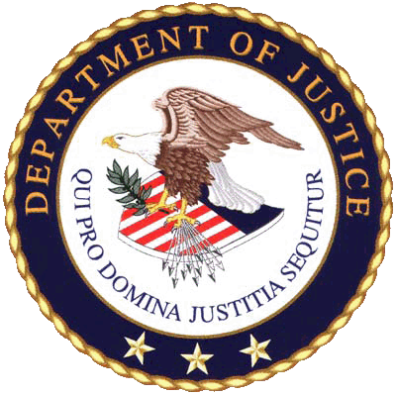

A N T I T R U S T D I V I S I O N

Congressional Submission
FY 2014 Performance Budget

Antitrust Division

FY 2014 Congressional Budget Submission

Table of Contents

I. Overview 2

A. Introduction 2

B. Issues, Outcomes, and Strategies 3

C. Full Program Costs 15

D. Performance Challenges 16

I. Summary of Program Changes 17

III. Appropriations Language and Analysis of Appropriations Language 18

IV. Program Activity Justification 19

A. Decision Unit: Antitrust 19

1. Program Description 19

2. Performance and Resource Tables 25

3. Performance Measurement Framework 30

4. Performance, Resources, and Strategies 31

5. Exemplar - Criminal 36

6. Exemplars – Civil 41

V. Program Offsets by Item 45

VI. Exhibits 46
A. Antitrust Division Organization Chart
B. Summary of Requirements
C. FY 2014 Program Increases/Offsets by Decision Unit
D. Resources by DOJ Strategic Goal and Strategic Objective
E. Justification for Base Adjustments
F. Crosswalk of 2012 Availability
G. Crosswalk of 2013 Availability
H. Summary of Reimbursable Resources
I. Detail of Permanent Positions by Category
J. Financial Analysis of Program Changes
K. Summary of Requirements by Grade
L. Summary of Requirements by Object Class

I. Overview

A. Introduction

The Antitrust Division is committed to its mission to promote economic competition through enforcing and providing guidance on antitrust laws and principles. Its vision is an environment in which U.S. consumers receive goods and services of the highest quality at the lowest price and sound economics-based antitrust enforcement principles are applied.

The Division supports the Department’s Strategic Goal II, Objective 2.6, “Protect the federal fisc and defend the interests of the United States.” In recent years, the Division has aggressively pursued far-reaching criminal cartel activity and important civil matters while reviewing a large number of premerger filings, many involving complex issues and global conglomerates. Merger volume steadily increased from 2003 through the first half of 2008, falling off at the end of 2008 based upon global economic conditions. Beginning in late 2009, as credit markets recovered and cash-rich companies regained business confidence, merger volume momentum gained speed and continues to increase in fiscal year 2013. To administer its caseload, the President’s Budget includes $160,410,000 in FY 2014, reflecting annual cost adjustments of $823,000 over the FY 2012 enacted level.

It is critical that the Division have adequate resources to keep abreast of a workload, which more and more involves large, multi-national corporations and anticompetitive behaviors that are pervasive and difficult to detect. By protecting competition across industries and geographic borders, the Division’s work serves as a catalyst for economic efficiency and growth with benefits accruing to both American consumers and American businesses. Electronic copies of the Department of Justice’s Congressional Budget Justifications and Capital Asset Plan and Business Case exhibits can be viewed or downloaded from the Internet using the Internet address: http://www.justice.gov/02organizations/bpp.htm.
- From FY 2009 through the end of FY 2012, as a result of the Division’s efforts, over $3.2 billion in criminal fines were obtained from antitrust violators.

- The Division is a key participant on the President’s Financial Fraud Enforcement Task Force, detecting and prosecuting mortgage fraud, securities and commodities fraud, and illegal schemes preying on funds designated to assist in America’s ongoing economic recovery as part of the American Recovery and Reinvestment Act. (see pg. 36)

- Intellectual property issues involving patents, copyrights, trademarks, or trade secrets are instrumental in the Division’s work. Invention and innovation are critical in promoting economic growth, creating jobs, and maintaining our competitiveness in the global economy. Antitrust laws ensure new proprietary technologies, products, and services are bought, sold, traded and licensed in a competitive environment.

B. Issues, Outcomes, and Strategies

Fundamental changes continue in the business marketplace, including the expanding globalization of markets, increasing economic concentration across industries, rapid technological change, significantly expanding numbers of business bankruptcies and failing firms, and substantial government investment in business enterprise. These factors, added to the existing number and intricacy of our investigations, significantly impact the Division’s overall workload. Many current and recent matters demonstrate the increasingly complex, large, and international nature of the matters encountered by the Division, as the following table and exemplars indicate.

Enforcement Program | Major Matter Exemplars
Criminal  DOJ Strategic Goal II  Objective 2.6 | Financial Fraud Enforcement (see Exemplar - pg.36)  (Real Estate, Municipal Bonds and Economic Recovery)  Automobile Parts (see Exemplar – pg 39)
Civil  Merger/Non-Merger  DOJ Strategic Goal II  Objective 2.6 | AT&T, Inc./T-Mobile USA, Inc. (see Exemplar – pg 41)  H&R Block, Inc./2SS Holdings, Inc. (TaxACT), (see Exemplar - pg. 42)  American Express, MasterCard and Visa – Credit Card Merchant Restraints (see Exemplar - pg. 44)

Globalization
Corporate leaders continue to seek a global presence as an element of long-term economic success, and more companies are transacting a significant portion of their business in countries outside of where they are located. For example, in the United States international trade (defined as exports and imports of goods and services) was $4.9 trillion in FY 2012.

The internationalization of the business marketplace has had a direct and significant impact on antitrust enforcement in general, and specifically, on the Antitrust Division’s workload. A significant number of the premerger filings received by the Division involve foreign acquirers, acquirees, major customers and competitors, and/or divestitures.
This also impacts our criminal enforcement program. The Division has witnessed a tremendous upsurge in international cartel activity in recent years. The Division places a particular emphasis on combating international cartels that target U.S. markets because of the breadth and magnitude of the harm that they inflict on American businesses and consumers. Of the grand juries opened through the end of FY 2012, approximately 67 percent were associated with subjects or targets located in foreign countries. Of the approximate $7.8 billion in criminal antitrust fines imposed by the Division between FY 1997 and the end of FY 2012, approximately 97 percent were imposed in connection with the prosecution of international cartel activity. In addition, approximately 65 foreign defendants from France, Germany, Japan, South Korea, Taiwan, the Netherlands, Norway, Sweden, Switzerland and the United Kingdom have served, or have been sentenced to serve, prison sentences in the United States as a result of the Division’s cartel investigations.

The Division’s criminal enforcement program overall, including enforcement against international cartels, has resulted in an increase in criminal fines. Up until 1994, the largest corporate fine imposed for a single Sherman Act count was $6 million. Today, fines of $10 million or more are commonplace, including many fines in excess of $100 million. In FY 2012, total criminal antitrust fines obtained reached a record $1.1 billion. Contributing to that total was a September 2012 sentence against AU Optronics Corporation. As a result of Division enforcement efforts, AU Optronics Corporation – a Taiwan-based liquid crystal display (LCD) producer – was sentenced to pay a $500 million fine for its participation in a five-year conspiracy to fix the prices of thin-film transistor LCD panels sold worldwide. The $500 million fine matches the largest fine ever imposed against a company for violating the U.S. antitrust laws. In addition, Yazaki Corp. agreed to plead guilty and pay a $470 million criminal fine in January 2012 for auto parts price fixing, representing the second largest criminal fine for an antitrust violation. The impact of these heightened penalties has been an increase in the participation of large firms in the Division’s Corporate Leniency Program, bringing more and larger conspiracies to the Division’s attention before they can inflict additional harm on U.S. businesses and consumers.

As discussed above, our work no longer takes place solely within the geographic borders of the U.S. In our enforcement efforts we find parties, potential evidence, and impacts abroad, all of which add complexity, and ultimately cost, to the pursuit of matters. Whether that complexity and cost results from having to collect evidence overseas or from having to undertake extensive inter-governmental negotiations in order to depose a foreign national, it makes for a very different, and generally more difficult investigatory process than would be the case if our efforts were restricted to conduct and individuals in the U.S. The markets and competitors affecting U.S. businesses and consumers are more international in scope, and the variety of languages and business cultures that the Division encounters has increased. Consequently, the Division must spend more for translators and translation software, interpreters, and communications, and Division staff must travel greater distances to reach the people and information required to conduct an investigation effectively and expend more resources to coordinate our international enforcement efforts with other countries and international organizations.

International Competition Advocacy - The Antitrust Division is actively working with international organizations to encourage the adoption, regulation, and enforcement of competition laws as worldwide consensus continues to grow that international cartel activity is pervasive and is victimizing consumers everywhere. Total cartel sales of $1.2 trillion in 2005 contained illegal overcharges of $300 billion, a 25 percent premium paid for by consumers and businesses worldwide.2 The Antitrust Division’s commitment to detect and prosecute international cartel activity is shared with foreign governments throughout the world, resulting in the establishment of antitrust cooperative agreements among competition law enforcement authorities across the globe. To date, the Division has entered into antitrust cooperation agreements with twelve foreign governments – Australia, Brazil, Canada, Chile, China, the European Union, Germany, India, Israel, Japan, Mexico and Russia.

In addition, antitrust authorities globally are becoming increasingly active in investigating and punishing cartels that adversely affect consumers. The Division is a strong advocate for effective anti-cartel enforcement around the world. As effective global cartel enforcement programs are implemented and criminal cartel penalties adopted, the overall detection of large, international cartels increases along with the Division’s ability to collect evidence critical to its enforcement efforts on behalf of American consumers. In the past decade, dozens of jurisdictions have increased penalties for cartel conduct, improved their investigative powers and introduced or revised amnesty programs. For example, Canada and Mexico have recently adopted or strengthened criminal sanctions for hard core cartel conduct. In addition, jurisdictions such as Australia, Canada and New Zealand have made revisions to their cartel amnesty policies making them more consistent with the United States.

Efforts such as these help enhance global antitrust enforcement and reduce the burden on law abiding companies that operate in international markets. In addition, they promote international uniformity and help bring cartel prosecution in line with international best practices.

The Division continues to prioritize international cooperation, procedural fairness and, where appropriate, antitrust policy convergence and pursues these goals by working closely with multilateral organizations, strengthening its bilateral ties with antitrust agencies worldwide, and working with countries that are in the process of adopting antitrust laws.

In October 2001, with leadership from the Antitrust Division, the International Competition Network (ICN), comprised of competition authorities from 13 jurisdictions, was launched. The Division continues to play an important role in achieving consensus, where appropriate, among antitrust authorities on sound competition principles and also provides support for new antitrust agencies in enforcing their laws and building strong competition cultures. As of 2012, the ICN has grown to include 123 agencies from 108 jurisdictions. The eleventh annual conference of the ICN was held in Rio de Janeiro, Brazil in April 2012 where ICN members adopted new materials on how to assess market dominance, resolve cartel cases and manage competition projects effectively.

Intellectual Property

Invention and innovation are critical in promoting economic growth, creating jobs, and maintaining our competitiveness in the global economy. Intellectual property laws create exclusive rights that provide incentives for innovation. Antitrust laws ensure that new proprietary technologies, products, and services are bought, sold, traded and licensed in a competitive environment. Together, antitrust enforcement and the protection of intellectual property rights create an environment that promotes the innovation necessary for economic success. Issues involving patents, copyrights, trademarks, or trade secrets, arise in the Division’s antitrust enforcement investigations, international competition advocacy, interagency initiatives, business review letters, and amicus filings in court cases. Three of these areas are highlighted below.

Patent Assets in Antitrust Cases - Recently there have been a number of proposed acquisitions that involve significant patent assets. The Division analyzes these issues closely to ensure competition is protected and invention and innovation are advanced. For example, in February 2012, the Antitrust Division closed its investigations of Google’s acquisition of Motorola Mobility and another investigation that also involved the acquisition of a very significant patent portfolio after concluding neither acquisition was likely to violate Section 7 of the Clayton Act.

These portfolios included patents that had been declared essential to a standard in the wireless industry, and for which the prior owner had made certain licensing commitments. The Division thoroughly examined the acquiring firms’ incentives and ability to exploit ambiguities in those commitments to raise rivals’ costs or foreclose competition. During the course of the Division’s investigations, several of the principal competitors involved in the transactions—Google, Apple and Microsoft—made commitments concerning their licensing policies for patents that have been declared essential to a standard, and which were encumbered by licensing commitments. The commitments made by Apple and Microsoft substantially lessened the Antitrust Division’s concerns about potential anticompetitive use of the patents. The Antitrust Division observed that Google’s commitments did not provide the same direct confirmation of its intended licensing policies.

Although the Division concluded that the acquisitions of these patent portfolios were not likely to substantially lessen competition, the Division noted its concerns about the potential inappropriate use of the declared standards-essential patents to disrupt competition and specifically limited its conclusion to the transfer of ownership rights and not to the exercise of those transferred rights. Since closing these investigations, the Division has continued to monitor closely the use of declared standards-essential patents for which the owner has made licensing commitments.

International Advocacy - The Division regularly engages in international competition advocacy projects promoting the use of sound analysis of competition when issues involving intellectual property rights arise in multinational fora, such as the World Intellectual Property Organization, the Organization for Economic Cooperation and Development, and the Asian Pacific Economic Cooperation, and in foreign jurisdictions, such as China. To ensure that U.S. businesses may appropriately utilize their important intellectual property rights, it is crucial that other jurisdictions approach the intersection of antitrust and intellectual property in ways that promote both competitive markets and respect for intellectual property rights. The Division devotes substantial time and effort to advocating that all jurisdictions enforce competition laws in ways that create the right incentives for innovative activity to take place.

Interagency Initiatives - Standard-setting activities can play a critical role in promoting innovation and are often used in information and communications sectors to facilitate interoperability of complementary products. The Division seeks to ensure that the standard-setting process, including the use of intellectual property in that process, is not used in a manner that harms consumers. The Division regularly participates in interagency activities that promote competition advocacy where antitrust, intellectual property, and standards issues are implicated.

DOJ-FTC Workshop - In December 2012, the Department of Justice and the Federal Trade Commission (FTC) held a joint public workshop on patent assertion entity (PAE) behavior, as distinct from “non-practicing entity” (NPE) activity, such as developing and transferring technology. By contrast, PAE activities often include purchasing patents from existing owners and seeking to maximize revenues by licensing the intellectual property to (or litigating against) manufacturers who are already using the patented technology.

The workshop provided a forum for industry participants, academics, economists, lawyers, and other interested parties to discuss the evolution of economic and legal analyses of PAE behavior, including patent acquisitions and licensing activity. The workshop consisted of a series of panels examining, among other topics, PAE behavior, the economics of IP licensing, industry experiences with PAE behavior, economic and legal theories and empirical work concerning PAE activity, and the potential efficiencies and harms to innovation and competition that this activity may generate.

DOJ-PTO Policy Statement - In January 2013, the Division and the U.S. Patent & Trademark Office (PTO) issued a policy statement recommending that the U.S. International Trade Commission (ITC) undertake fact-based, case-specific decisions regarding the enforcement of a patent essential to a standard that is encumbered by a commitment to license that patent on reasonable and non-discriminatory (RAND) or fair, reasonable, and nondiscriminatory (FRAND) terms to those implementing the standard. The ITC must consider the effect of its exclusion order remedies on competitive conditions in the U.S. economy and on U.S. consumers as part of its public-interest analysis. An exclusion order based on such patents may be in the public interest in limited circumstances. However, the public interest may be inconsistent with the issuance of an exclusion order in cases where the infringer is acting within the scope of the patent holder’s F/RAND commitment and is able, and has not refused, to license the patent on F/RAND terms.

DOJ-FTC Comments – In early 2013, the Division participated in the PTO’s roundtable on its proposed regulations requiring periodic and timely recordation of a patent’s real-party-in-interest. After that roundtable, the Division submitted joint comments with the FTC supporting the PTO’s efforts and proposed regulations. One serious question—but by no means the only one—that technology companies confront is who owns the patents that they may want to use. The answer is often unclear because there is no requirement to use the PTO’s system of recording patent assignments and transfers and no requirement that the true, controlling entity be disclosed. Faced with uncertainty, companies designing new products may find it difficult to weigh the relative merits, likelihood of licensing, and licensing costs of competing technologies. Requiring the disclosure of the real-party-in-interest will help improve the efficiency of the IP licensing marketplace. Advocacy in support of more efficient IP licensing furthers the Division’s mission to promote competition across industries.

Economic Concentration

Ongoing economic concentration across industries and geographic regions also increases the Division’s workload. Where there is a competitive relationship between or among the goods and/or services produced by the parties, the analysis necessary for thorough merger review becomes more complex. Competitive issues and efficiency defenses are more likely to surface in such reviews, adding complexity and cost to the Division’s work.

Figure 1

As shown in Figure 1, the overall economic downturn that began in calendar year 2008 resulted in a drop in merger deals in 2009 and the year finished with $767 billion in U.S. merger value. However, merger and acquisition activity improved in calendar years 2010 through 2011 and increased slightly in 2012. Worldwide merger and acquisition volume in calendar year 2012 was roughly in line with volume in 2011 and ended the year at $2.6 trillion.3
The economic slump has affected companies around the globe - troubles in the sovereign debt markets and the looming fiscal cliff crisis in the United States had companies wary of jumping into big deals. However, record amounts of cash and plentiful financing at bargain-basement interest rates are fueling a merger comeback for 2013. This year's U.S.-based M&A activity is off to its fastest start since 2000, according to data from Dealogic. Nonetheless, while bankers and lawyers predict an uptick from the last several years, few expect M&A activity to hit pre-crisis levels. 4

Technological Change and the Changing Face of Industry

Technological change continues to create new businesses and industries virtually overnight, and its impact on the overall economy is enormous. The emergence of new and improved technologies, such as wireless communications, Voice over Internet Protocol (VoIP), biometrics, hand-held computing and online security, continues and intensifies.
We will see even more advances in technology in coming years as the telecommunications upheaval continues to transform traditional industry business models. One such transformation is in wireless communication and connectivity. There were an estimated 321.7 million wireless subscribers in the United States, home to the most mobile internet users in the world, as of June 2012 according to the Cellular, Telecommunications and Internet Association (CTIA) Wireless Quick Facts Report.5

Clearly, being ‘connected’ has become essential to the American daily lifestyle, and this connectivity demand continues to result in rapidly emerging newer and faster networks, applications and equipment. A June 2012 Pew Internet & American Life Project Report published by the Pew Research Center found that as of April 2012, 88 percent of U.S. adults have a cell phone of some kind. Of this group, more than half (55 percent) use their phone to go online.6

As more consumers turn to high-speed broadband, wireless Internet access, and search for more efficient and cost effective methods of communication, expanding technologies such as Voice over Internet Protocol (VoIP), or what is also known as Broadband Telephony, stand to grow dramatically over the next several years. Surveys by the Pew Research Center’s Internet & American Life Project in February 2007 showed that 8 percent of American adult internet users (6 percent of all American adults) had placed calls online and 2 percent of internet users were making calls on any given day. Just four years later, in their May 2011 survey, the Pew Research Center found that 24 percent of American adult internet users (19 percent of all American adults) had placed calls online and 5 percent were making calls on any given day.7

The continuing evolution of technology, as it reshapes both industries and business processes worldwide, creates new demands on the Antitrust Division. The economic paradigm is shifting so rapidly that the Division must employ new analytical tools, which allow it to respond quickly and appropriately. It must be vigilant against anticompetitive behavior in the new economy where the Internet and cutting-edge information technology may facilitate the rapid entry and dominance of emerging markets.

Technological Change and Information Flows

Technological change is occurring at a blistering pace, as evidenced by the proliferation of wireless communication enhancements; the near daily evolution of mobile handheld devices, computer components, peripherals and software; and the growing use of video teleconferencing technology to communicate globally.

As the tools of the trade become more sophisticated, there appears to be a corresponding growth in the subtlety and complexity with which prices are fixed, bids are rigged, and market allocation schemes are devised. The increased use of electronic mail, and even faster, more direct methods of communication, such as text and instant messaging, has fostered this phenomenon. Moreover, the evolution of electronic communication results in an increase in the amount and variety of data and materials that the Antitrust Division must obtain and review in the course of an investigation. In addition to hard-copy documents, telephone logs, and other information from public sources, including the Internet, the Division now regularly receives magnetic tapes, CD’s, and computer servers containing the e-mail traffic and documents of companies under investigation.
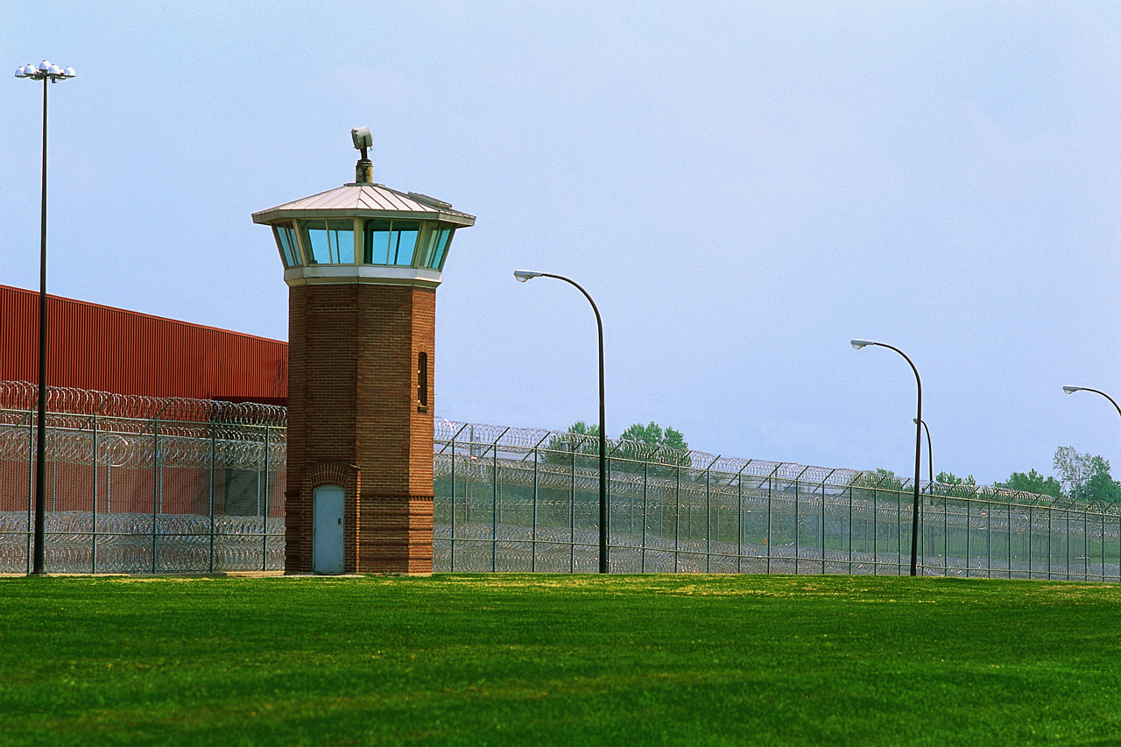Results

While specific GPRA Performance Measures are addressed in the Decision Unit Justification section of this submission, several interesting statistics relative to the Division’s performance include:

- From FY 2009 through the end of FY 2012, as a result of the Division’s efforts, over $3.2 billion in criminal fines were obtained against antitrust violators. In FY 2012 alone, over $1.1 billion in criminal fines were obtained, making FY 2012 the year with the highest annual amount of obtained criminal fines in the Division’s history.

- In the area of criminal enforcement, the Division continues to move forcefully against hard-core antitrust violations such as price-fixing, bid rigging and market allocation agreements. A significant number of our prosecutions have involved international price-fixing cartels, impacting billions of dollars in U.S. commerce. Since FY 1997, defendants have been sentenced to pay approximately $7.8 billion in criminal fines to the U.S. Treasury, including more than $3.8 billion just since the beginning of FY 2008.

- The Division believes that individual incarceration has a greater deterrent effect than fines alone and continues to emphasize prison terms for individuals who participate in antitrust criminal behavior. In FY 2012, as the result of Division enforcement efforts, 35 corporations and 55 individuals were sentenced due to antitrust violations. Prison sentences between FY 2000 and the end of FY 2012 were an average of approximately 22 months, more than twice the 8-month average sentence of the 1990’s. Prison sentences since FY 1990 have resulted in approximately 621 years of imprisonment in cases prosecuted by the Antitrust Division, with 208 defendants sentenced to imprisonment of one year or longer.

- Coupled with the increasing frequency and duration of defendants’ incarceration was a rise in monetary restitution by criminal defendants. From FY 2004 through the end of FY 2012, restitution generated by the Division was approximately $92 million.

- Despite a workload of increasingly complex cases, the Antitrust Division has made great strides in combating anticompetitive behavior across industries and geographic borders and has saved consumers billions of dollars by ensuring a competitive and innovative marketplace. Since FY 1998, the first year for which data is available, the Division, through its efforts in all three enforcement areas - merger, criminal and civil non-merger - is estimated, conservatively, to have saved consumers $36 billion.

Revenue Assumptions

Estimated FY 2013 - 2014 filings and fee revenue take into account the relative optimism of current medium-range economic forecasts. The February 2013 Congressional Budget Office, Budget and Economic Outlook anticipates that economic activity will expand slowly in calendar year 2013 but increase more rapidly in calendar year 2014.8

Premerger Filing Fee Thresholds
Effective Feb 11, 2013
Value of Transaction Filing Fee
Lower: $70.9M - <$141.8M $45,000
Middle: $141.8M - <$709.1M $125,000
Upper: $709.1M plus $280,000

Figure 2
(Consistent with statutory direction, pre-merger filing fee threshold amounts are adjusted annually based on the U.S. Gross Domestic Product Index and are reflected in the table above)

Renewed confidence in economic conditions beginning in late 2009 resulted in a 67 percent increase in Hart-Scott-Rodino (HSR) filings and a 73 percent increase in fee revenue in FY 2010. An increased level of merger activity continued throughout FY 2012 and is expected to continue throughout fiscal years 2013 through 2014.

Based upon estimates calculated by the Congressional Budget Office and the Federal Trade Commission (FTC), fee collections of $235 million for FY 2013 and $204.6 million for FY 2014 are expected. HSR filing fee revenue is collected by the FTC and divided evenly with the Antitrust Division.

The President’s Budget proposes to increase the HSR fees, to take effect in FY 2015, and index them for the percentage annual change in the gross national product. The proposal would also create a new merger fee category for mergers valued at over $1 billion.

Environmental Accountability

The Antitrust Division is mindful of responsible environmental management and has implemented processes to encourage awareness throughout the Division, including:

- Adherence to environmental standards during the procurement process to ensure products meet the recommended guidelines of the Department of Energy's energy efficiency standards, the Environmental Protection Agency's designated recovered material and bio-based products specifications, and the Department of Justice's Green Purchase Plan requirements.

- The Antitrust Division's central Washington D.C. Liberty Square building meets many LEED (Leadership in Energy and Environmental Design) criteria and includes many environmentally sound features including: zoned climate control for efficiencies in heating and air conditioning, motion sensored overhead lighting to minimize wasted energy in unoccupied space, and a recycling program throughout the building for paper, plastic, glass, and newspaper.

- The Division encourages employees to print documents only when absolutely necessary and, whenever possible, print double-sided in an effort to save paper.

The Division will continue to implement additional programs as further guidance is received from the Department, Administration and Congress.

Summary

The Division is continually challenged by an increasingly international and complex workload that spans enforcement areas and requires considerable resources to manage. With our children destined to inherit the resulting markets, the importance of preserving economic competition in the global marketplace cannot be overstated. The threat to consumers is very real, as anticompetitive behavior leads directly to higher prices and reduced efficiency and innovation. In recognition of the importance of its mission, the Antitrust Division requests an FY 2014 budget increase of $823,000 to address annual cost adjustments and a total appropriation of $160,410,000 in support of 830 positions.

The FY 2014 Antitrust Division budget request of $160,410,000 supports Departmental Strategic Goal II: Prevent Crime, Protect the Rights of the American People and Enforce Federal Law. The Division’s criminal and civil programs are both included in Strategic Objective 2.6: Protect the federal fisc and defend the interests of the United States.

Figure 3

C. Full Program Costs

The Antitrust Division contains one Decision Unit (Antitrust). Within this Decision Unit the Division supports the Department’s Strategic Goal II: Prevent Crime, Protect the Rights of the American People and Enforce Federal Law. This Strategic Goal defines the two broad program areas:

    - Criminal Enforcement
    - Civil Enforcement

In recent years, approximately 40 percent of the Division’s budget and expenditures can be attributed to its criminal program and approximately 60 percent of the Division’s budget and expenditures can be attributed to its civil program. The FY 2014 budget request assumes this same allocation.

This budget request incorporates all costs to include mission costs related to cases and matters, mission costs related to oversight and policy, and overhead.

D. Performance Challenges

External Challenges

As detailed in the Issues, Outcomes, and Strategies section, the Antitrust Division faces many external challenges that require flexibility and adaptability in order to pursue its mission. These external challenges include:

- Globalization of the business marketplace
- Increasing economic concentration across industries and geographic regions
- Rapid technological change

Internal Challenges

Much like its external challenges, highly unpredictable markets and economic fluctuations influence the Division’s internal challenges. To accommodate these ever-changing factors, the Division must continuously and diligently ensure proper allocation and prudent use of its resources.

Information Technology (IT) Expenditures

The Antitrust Division’s IT budget will continue to support several broad Information Technology areas essential to carrying out its mission. These Information Technology areas include:

- Data Storage –Electronic storage and processing capability, vital to the mission of the Antitrust Division, continues to expand, growing exponentially since FY 2003, when 12 terabytes (12 trillion bytes) of capacity readily satisfied Division demands. By FY 2010 requirements surpassed 100 terabytes and the Division expects electronic analytical capacity needs to reach 1,284.3 terabytes or 1.2 petabytes by FY 2014 (1 petabyte is the equivalent of 20 million 4-drawer file cabinets filled with text).
- Data Security - - Monitoring and effecting actions to ensure that system design, implementation, and operation address and minimize vulnerabilities to various threats to computer security, including carrying out security planning, risk analysis, contingency planning, security testing, intrusion detection, and security training.

- Litigation Support Systems - - Providing litigation support technologies that encompass a wide range of services and products that help attorneys and economists acquire, organize, develop, and present evidence. Providing courtroom presentation and related training to the legal staff to develop staff courtroom skills and practice courtroom presentations using state-of-the-art technology.

- Office Automation - - Providing staff technological tools comparable to those used by opposing counsel, thereby ensuring equitable technological capabilities in antitrust litigation. These tools are used for desktop data review and analysis, computer-based communication, the production of time-critical and sensitive legal documents, and preparing presentations and court exhibits.

- Management Information Systems - - Developing, maintaining, and operating data and information systems which support management oversight, direction of work, budget, and resources of the Division. Various tracking systems help ensure timely and efficient conduct of the Division’s investigations through use of automated, web-based tools.

- Telecommunications - - Developing, providing, maintaining, and supporting networks and services required for voice and data communications among the Division’s offices, with outside parties, and in support of federal telework objectives.

- Web Support – Developing and maintaining the Division’s Internet and internal ATRnet site. Posting case filings, documents and data related to cases and investigations; designing and developing new applications, providing public access to key Division information, and ensuring compliance with web standards and guidelines, including guidelines for usability and accessibility.

I. Summary of Program Changes

Item Name | Description |  |  |  | See Page
 | Antitrust Division | Pos. | FTE | Dollars ($000)
Position/FTE Adjustment | Permanent Position reduction | -50 | 0 | $0 | 45

III. Appropriations Language and Analysis of Appropriations Language

Appropriations Language

Salaries and Expenses, Antitrust Division

For expenses necessary for the enforcement of antitrust and kindred laws, [$160,564,000] $160,410,000 to remain available until expended: Provided, That, notwithstanding any other provision of law, fees collected for premerger notification filings under the Hart-Scott-Rodino Antitrust Improvements Act of 1976 (15 U.S.C. 18a), regardless of the year of collection (and estimated to be [$117,500,000] $102,300,000 in fiscal year [2013] 2014), shall be retained and used for necessary expenses in this appropriation, and shall remain available until expended: Provided further, That the sum herein appropriated from the general fund shall be reduced as such offsetting collections are received during fiscal year [2013] 2014; so as to result in a final fiscal year [2013] 2014 appropriation from the general fund estimated at [$43,064,000] $58,110,000.

Analysis of Appropriations Language

No substantive changes proposed.

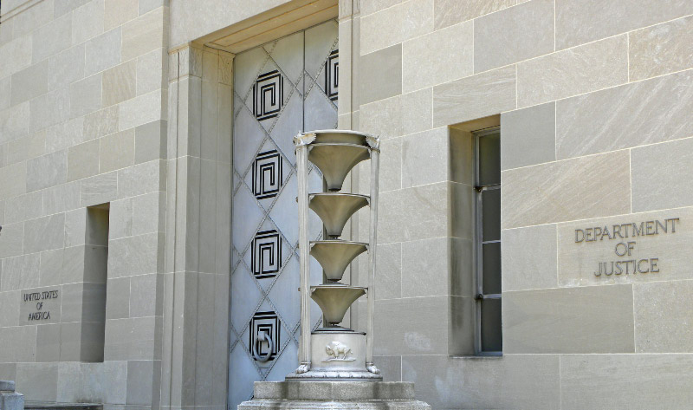

IV. Program Activity Justification

A. Decision Unit: Antitrust

Antitrust Division
Fiscal Year 2014 Congressional Budget Submission
Decision Unit Justification
(dollars in thousands)
 | Direct | Estimate
Decision Unit: Antitrust - TOTAL | Positions | FTE | Amount
2012 Enacted | 880 | 705 | $159,587
2013 Continuing Resolution 0.612% Increase | 880 | 676 | $977
Base and Technical Adjustments | 0 | 0 | $-154
2014 Current Services | 880 | 676 | $160,410
2014 Program Changes | -50 | 0 | $0
2014 Request | 830 | 676 | $160,410
Total Change 2012 - 2014 | -50 | -29 | $823
Antitrust Division – Information Technology Breakout (of Decision Unit Total)
2012 Enacted | 38 | 36 | $24,678
2013 Continuing Resolution 0.612% Increase | 35 | 33 | $151
Base and Technical Adjustments | 0 | 0 | $-28
2014 Current Services | 35 | 33 | $24,801
2014 Request | 35 | 33 | $24,801
Total Change 2012 - 2014 | 0 | -3 | $123

1. Program Description

The Antitrust Division promotes competition and protects consumers from economic harm by enforcing the Nation’s antitrust laws. Free and open competition benefits consumers by ensuring lower prices and new and better products. The perception and reality among consumers and entrepreneurs that the antitrust laws will be enforced fairly and fully is critical to the economic freedom of all Americans. Vigorous competition is also critical to assure the rapid innovation that generates continued advances in our standard of living and our competitiveness in world markets.

At its highest level, the Division has two main strategies - Criminal and Civil. All of the Division’s activities can be attributed to these two strategies and each strategy includes elements related to investigation, prosecution, and competition advocacy. To direct its day-to-day activities, the Division has established five supervisory Deputy Assistant Attorney General (DAAG) positions reporting directly to the Assistant Attorney General. Each of these DAAGs has oversight of a specific program including Civil Enforcement, Criminal Enforcement, Litigation, Operations, and Economic Analysis.

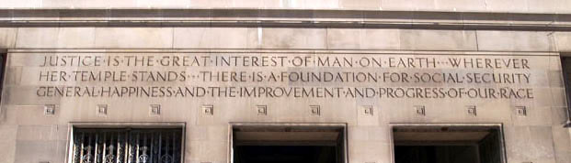

Criminal Enforcement - Within the Criminal strategy, the Antitrust Division must address the increased globalization of markets, constant technological change, and a large number of massive criminal conspiracies the Division is encountering. These matters transcend national boundaries, involve more technologically advanced and subtle forms of criminal behavior, and impact more U.S. businesses and consumers than ever before. The requirements -- whether in terms of staff time, travel and translation costs, or automated litigation support -- of fighting massive criminal conspiracies effectively is great. Matters such as the Division’s ongoing investigations in the municipal bond investments market and real estate foreclosure auctions (page 36) exemplify the increasingly complex nature of Division workload in the criminal area and demonstrate that successful pursuit of such matters takes time and resources.

Civil Enforcement - Under the Civil strategy, the Division seeks to promote competition by blocking potentially anticompetitive mergers before they are consummated and pursuing non-criminal anticompetitive behavior such as group boycotts and exclusive dealing. The Division’s Civil strategy seeks to maintain the competitive structure of the national economy through investigation and litigation of instances in which monopoly power is sought, attained, or maintained through anticompetitive conduct and by seeking injunctive relief against mergers and acquisitions that may tend substantially to lessen competition. The Division’s Merger Review work can be divided into roughly three categories:

- Review of HSR transactions brought to our attention by statutorily mandated filings

- Review of non-HSR transactions (those not subject to HSR reporting thresholds); and

- Review of bank merger applications.

Competition Advocacy - As an advocate of competition, the Antitrust Division seeks the elimination of unnecessary regulation and the adoption of the most competitive means of achieving a sound economy through a variety of activities on the national and international stages. Areas in which the Division pursues competition advocacy initiatives include:

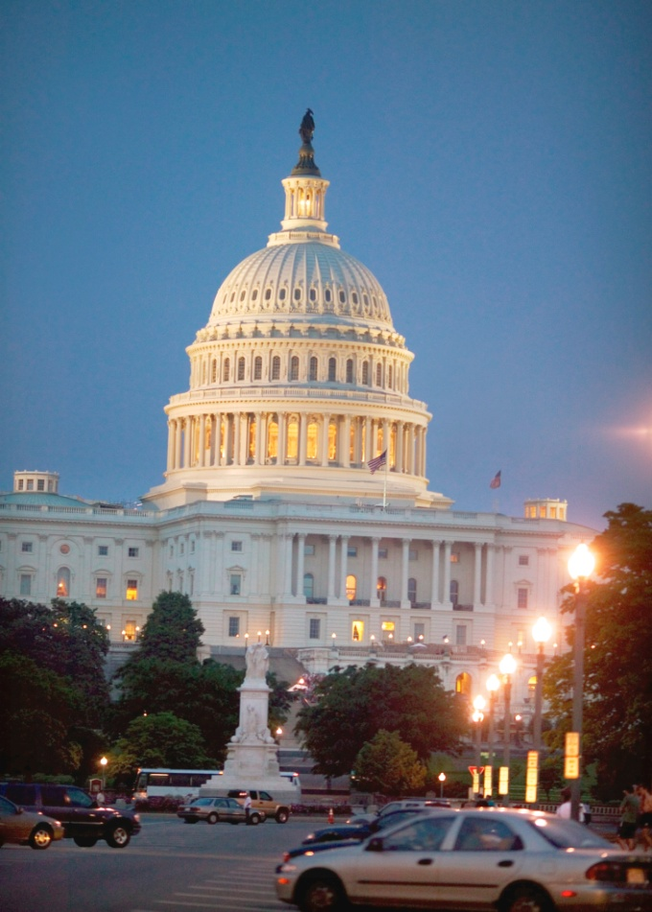
Regulatory Issues - The Antitrust Division actively monitors the pending actions of federal, state, and local regulatory agencies either as statutorily mandated, as in the case of telecommunication and banking markets, or through review of those agencies’ dockets and industry or other publications and through personal contacts in the industries and in the agencies. Articulation of a pro-competitive position may make the difference between regulations that effectively do no antitrust harm and actively promote competitive regulatory solutions and those that may negatively impact the competitiveness of an industry. Examples of regulatory agencies before which the Division has presented an antitrust viewpoint include the Federal Communications Commission, Securities and Exchange Commission and the Federal Energy Regulatory Commission.

Review of New and Existing Laws - Given the dynamic environment in which the Antitrust Division must apply antitrust laws, refinements to existing law and enforcement policy are a constant consideration. Division staff analyze proposed legislation and draft proposals to amend antitrust laws or other statutes affecting competition. Many of the hundreds of legislative proposals considered by the Department each year have profound impacts on competition and innovation in the U.S. economy. Because the Division is the Department’s sole resource for dealing with competition issues, it significantly contributes to legislative development in areas where antitrust law may be at issue.

For example, the Division has filed numerous comments and provided testimony before state legislatures and real estate commissions against proposed legislation and regulations that forbid buyers’ brokers from rebating a portion of the sales commission to the consumer or that require consumers to buy more services from sellers’ brokers than they may want, with no option to waive the extra items.
Education, Speeches, and Outreach – The Division seeks to reach the broadest audience in raising awareness of competition issues and, to do so, provides guidance through its business review program, outreach efforts to business groups and consumers, and the publication of antitrust guidelines and policy statements aimed at particular industries or issues. Division personnel routinely give speeches addressing these guidelines and policy statements to a wide variety of audiences including industry groups, professional associations, and antitrust enforcers from international, state, and local agencies.

In addition, the Division seeks opportunities to deploy its employees to serve the needs of the federal government for a broad variety of policy matters that involve competition policy to include:

- Detailing Division employees to Congressional committees, federal agencies and other parts of the Administration and

- Actively participating in White House interagency task forces in areas such as Internet Policy Principles, standard setting, and Accountable Care Organization (ACO) implementation.

International Advocacy – The Antitrust Division continues to work toward bringing greater cooperation to international enforcement, promoting procedural fairness and transparency both at home and abroad, and achieving greater convergence, where appropriate, to the substantive antitrust standards used by agencies around the world. The Division pursues these goals by working closely with multilateral organizations, strengthening its bilateral ties with antitrust agencies worldwide, and working with countries that are in the process of adopting antitrust laws. One of the most notable examples of the Division’s international efforts includes its participation in the International Competition Network (ICN). In April 2012, at its 11th annual conference in Rio de Janeiro, Brazil with more than 450 delegates and competition experts from more than 80 antitrust agencies in attendance, the ICN launched and approved three new initiatives on international enforcement cooperation, the investigative process in competition cases and working with the courts. The ICN also adopted new materials on unilateral conduct investigations, raising anti-cartel awareness and explaining the benefits of competition.

With support from the Antitrust Division, the Organization for Economic Cooperation and Development (OECD) and the International Competition Network (ICN) are assisting substantially in Division efforts to achieve a more transparent, and where appropriate, uniform worldwide application of central antitrust enforcement principles.

Laws Enforced: There are three major federal antitrust laws: the Sherman Antitrust Act (pictured below), the Clayton Act and the Federal Trade Commission Act. The Sherman Antitrust Act has stood since 1890 as the principal law expressing the United States’ commitment to a free market economy. The Sherman Act outlaws all contracts, combinations and conspiracies that unreasonably restrain interstate and foreign trade. The Department of Justice alone is empowered to bring criminal prosecutions under the Sherman Act. The Clayton Act is a civil statute (carrying no criminal penalties) that was passed in 1914 and significantly amended in 1950. The Clayton Act prohibits mergers or acquisitions that are likely to lessen competition. The Federal Trade Commission Act prohibits unfair methods of competition in interstate commerce, but carries no criminal penalties.

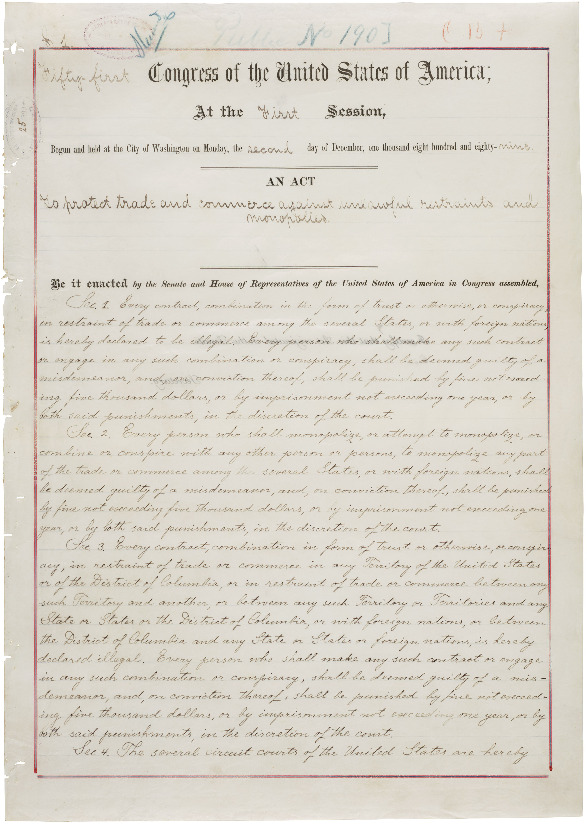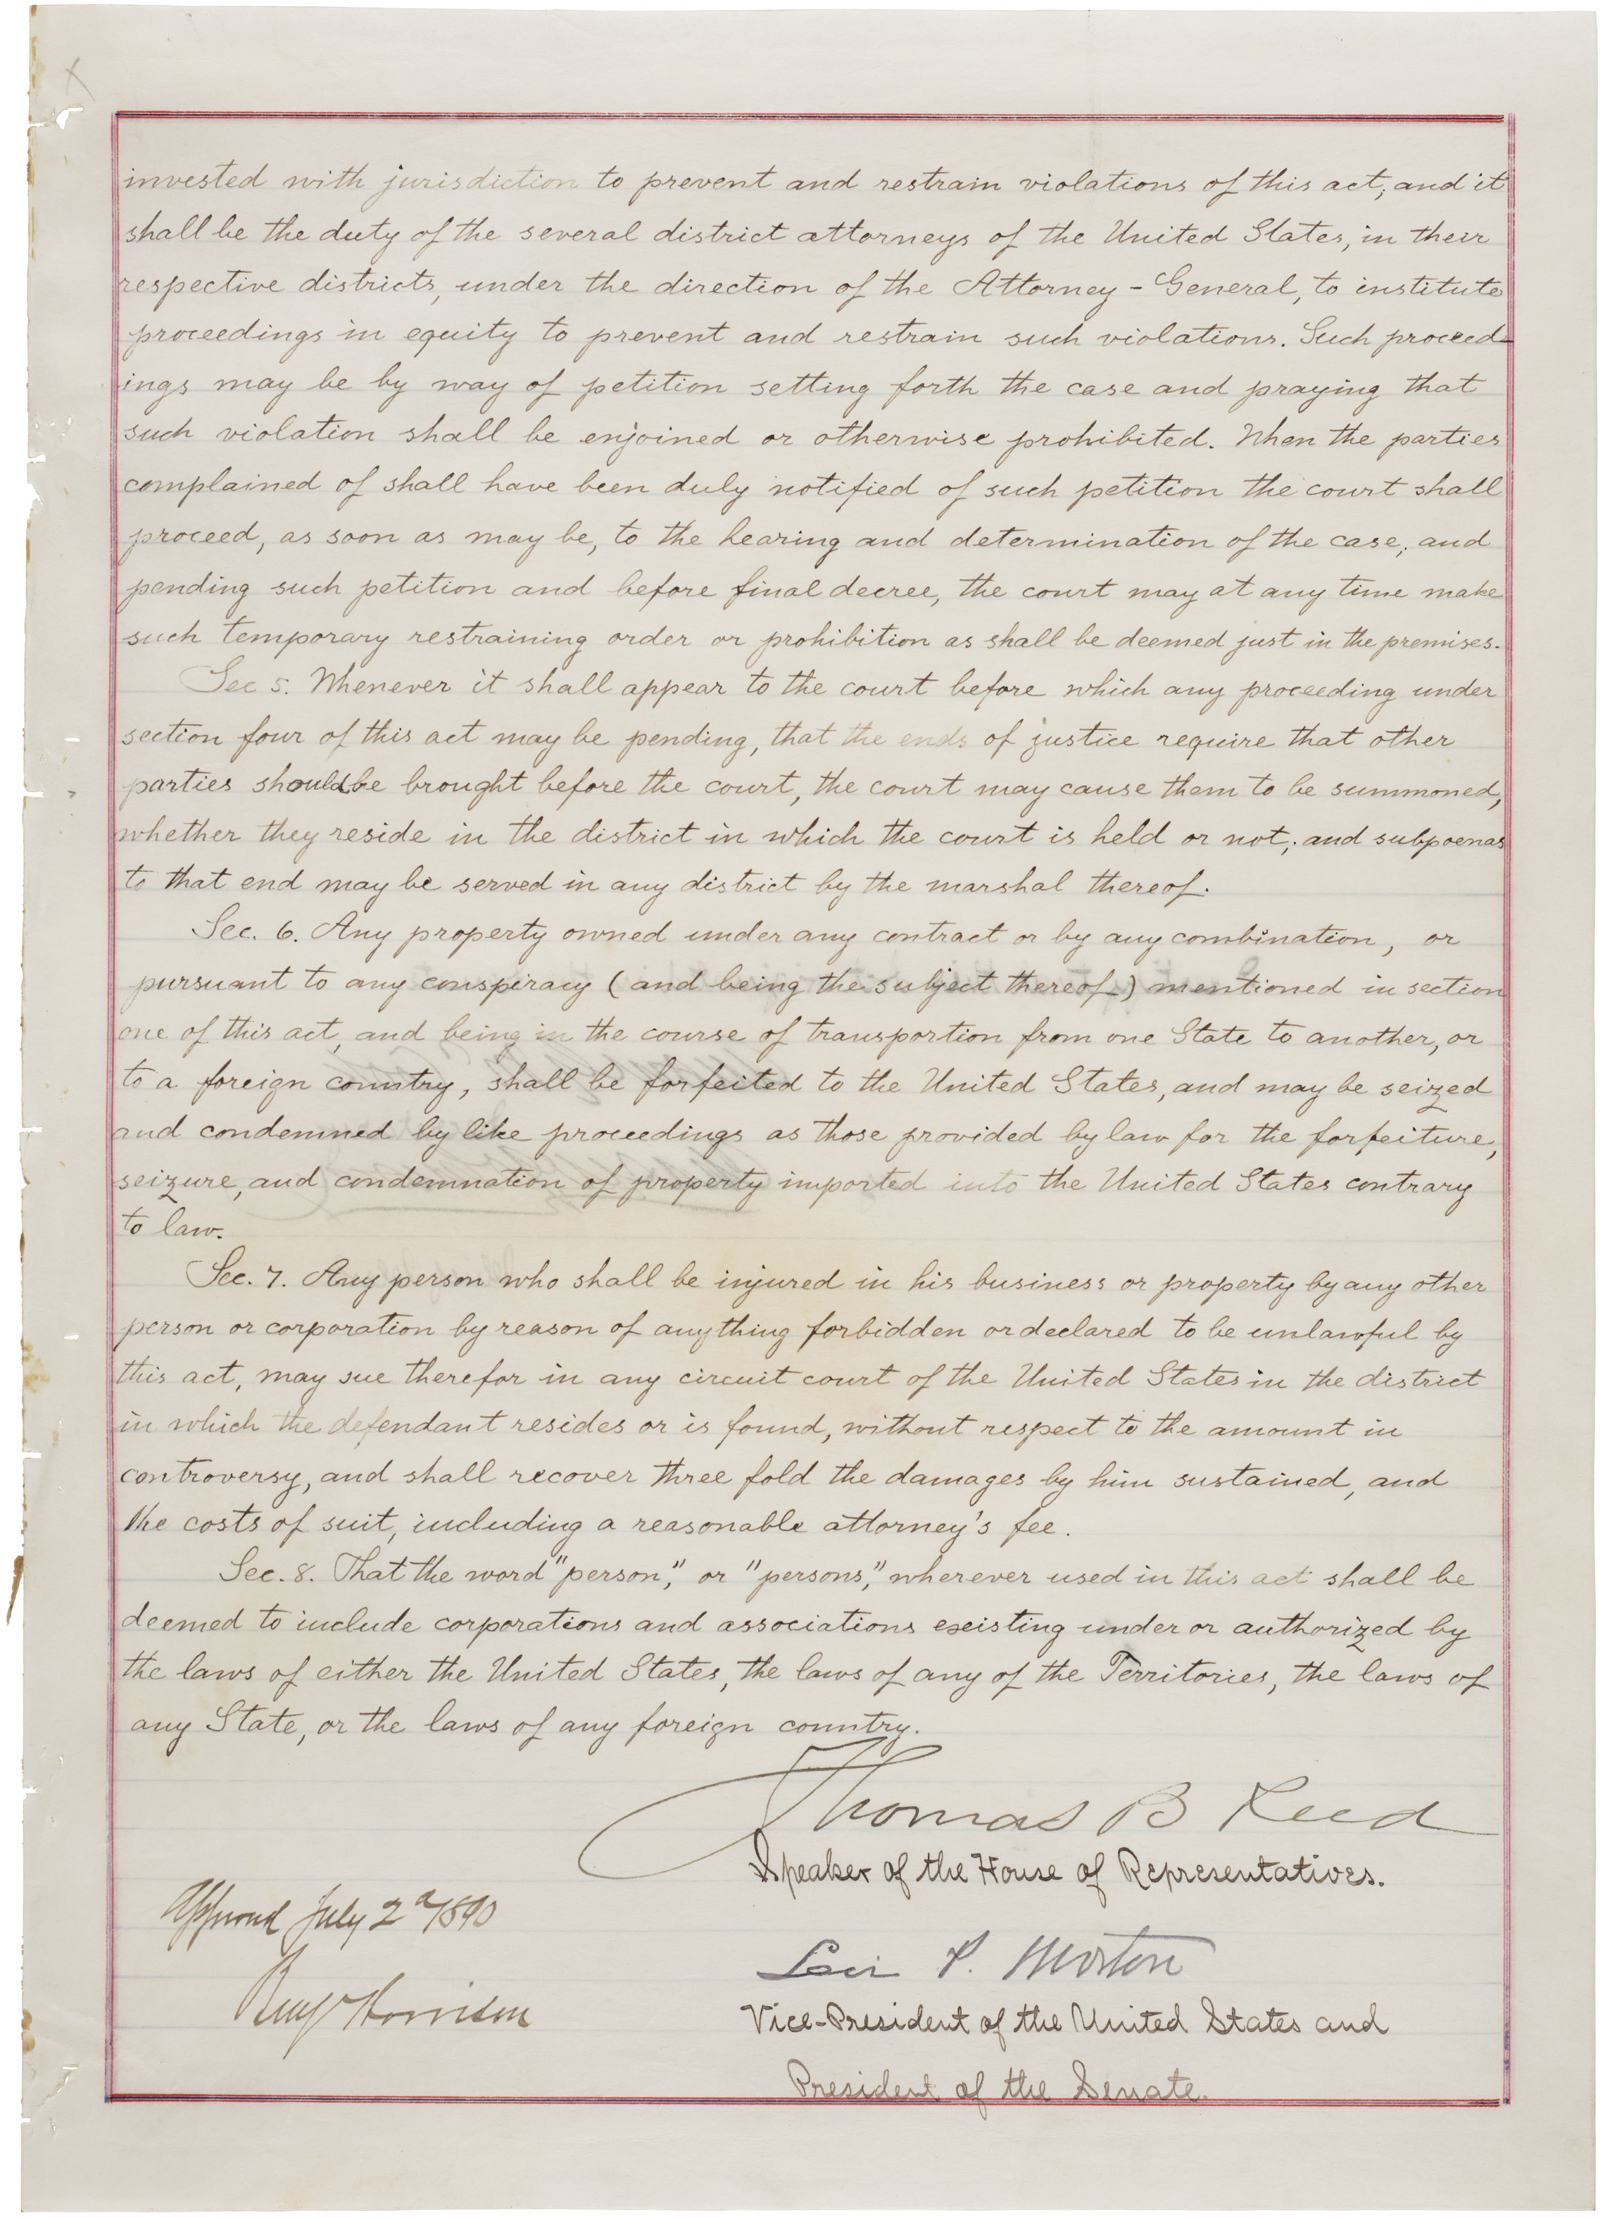
(An Act to protect trade and commerce against unlawful restraints and monopolies ("Sherman Antitrust Act"), July 2, 1890; 51st Congress, 1st Session, Public Law #190; Record Group 11, General Records of the U.S.)

 | 2. Performance and Resource Tables
 | Decision Unit/Program: Antitrust
 | DOJ Strategic Goal II: Strategic Objective 2.6: Criminal, Civil
 |  | WORKLOAD/RESOURCES |  |  |  | Target |  | Actual |  |  |  | Projected |  |  |  | Changes |  |  | Requested  (Total)
 |  |  |  |  | FY 2012 |  | FY 2012 |  |  |  | FY 2013 CR |  |  | Current  Services  Adjustments and FY 2014 Program Changes |  |  |  | FY 2014  Request
Workload - Number of HSR Transactions Received |  |  |  | 1,635 |  |  | 1,436 |  |  | 1,635 |  |  |  |  | 0 |  |  | 1,635
Total Costs and FTE |  |  |  | FTE |  | $000 | FTE |  | $000 | FTE |  |  | $000 |  | FTE |  | $000 | FTE |  | $000
Antitrust |  |  |  | 851 |  | $159,587 | 705 |  | $165,459 | 676 |  |  | $160,564 |  | 0 |  | $-154 | 676 |  | $160,410
TYPE/ Strategic Objective |  |  | PERFORMANCE/RESOURCES | FY 2012 |  |  | FY 2012 |  |  | FY 2013 CR |  |  |  |  | Current  Services  Adjustments and FY 2014 Program Changes |  |  | FY 2014  Request
Program Activity |  |  | 1. Criminal | FTE |  | $000 | FTE |  | $000 | FTE |  |  | $000 |  | FTE |  | $000 | FTE |  | $000
 |  |  |  | 340 |  | $63,835 | 282 |  | $66,184 | 284 |  |  | $64,226 |  | 0 |  | $-62 | 284 |  | $64,164
Performance Measure – Criminal |  |  | Number of Active Grand Juries | 95 |  |  | 87 |  |  | 75 |  |  |  |  | 0 |  |  | 75
 |  |  | Dollar Volume of U.S. Commerce Affected in Relevant Markets Where Pleas/Cases Favorably Resolved ($ in millions) | Not Projected |  |  | $4,469 |  |  | Not Projected |  |  |  |  | Not Projected |  |  | Not Projected
Program Activity |  |  | 2. Civil | FTE |  | $000 | FTE |  | $000 | FTE |  |  | $000 |  | FTE |  | $000 | FTE |  | $000
 |  |  |  | 511 |  | $95,752 | 423 |  | $99,275 | 392 |  |  | $96,338 |  | 0 |  | $-92 | 392 |  | $96,246

 |  |  |  |  |  |  |  |  |  |  |  |  |  |  |  |  |  | Target |  | Actual |  |  |  |  | Projected |  |  |  | Changes |  |  |  |  | Requested (Total)
 |  |  | TYPE/ Strategic Objective |  |  |  |  | PERFORMANCE/RESOURCES |  |  |  |  | FY 2012 |  |  |  | FY 2012 |  |  |  |  |  | FY 2013 CR |  |  |  | Current Services  Adjustments and FY 2014 Program Changes |  |  |  | FY 2014  Request
 |  | Performance Measure – Merger |  |  |  |  | Number of Preliminary Inquiries Opened |  |  |  |  | 110 |  |  |  | 74 |  |  |  |  |  | 70 |  |  |  | 0/0 |  |  |  | 70
 |  | Performance Measure – Civil Non-Merger |  |  |  |  | Number of Active Investigations |  |  |  |  | 77 |  |  |  | 46 |  |  |  |  |  | 70 |  |  |  | 0/0 |  |  |  | 70
 |  | Performance Measure – Civil Merger and Non-Merger |  |  |  |  | Dollar Volume of U.S. Commerce Affected in Relevant Markets for all Merger Wins and All Non-Merger Pleas/Cases Favorably Resolved ($ in millions) |  |  |  |  | Not Projected |  |  |  | $437,410 |  |  |  |  |  | Not Projected |  |  |  | Not Projected |  |  |  | Not Projected
 | Outcome – Criminal, Civil (Merger and Civil Non-Merger)
 | Consumer Savings |  |  |  |  | Criminal: Total Dollar Value of Savings to U.S. Consumers ($ in millions) |  |  |  | Not Projected |  |  |  | $447 |  |  |  |  | Not Projected |  |  |  |  | Not Projected |  |  |  | Not Projected
 |  |  |  |  |  | Civil: Total Civil (Merger and Non-Merger) Dollar Value of Savings to U.S. Consumers ($ in millions) |  |  |  | Not Projected |  |  |  | $8,965.6 |  |  |  |  | Not Projected |  |  |  |  | Not Projected |  |  |  | Not Projected
 | Success Rates |  |  |  |  | Criminal - Percentage of Cases Favorably Resolved |  |  |  | 90% |  |  |  | 93% |  |  |  |  | 90% |  |  |  |  | 0 |  |  |  | 90%
 |  |  |  | Civil - Percentage of Cases Favorably Resolved |  |  |  |  | 80% |  | 100% |  |  |  | 80% |  |  |  |  |  | 0 |  |  |  |  | 80%

TABLE DATA DEFINITIONS:

Program Activity Data Definition, Validation, Verification, and Limitations:

Criminal, Civil Merger and Civil Non-Merger performance measure target adjustments for FY 2013 through FY 2014 projections are based on an analysis of FY 2002 through FY 2012 actual amounts.

Criminal Performance Measure:
During the course of the year, if the Antitrust Division subpoenas individuals to, questions witnesses before, presents information to, or otherwise has contact with a grand jury for one of our investigations, it is considered an Active Grand Jury. In some instances, the Division may conduct an investigation during the course of the year, but not bring witnesses before or present evidence to the applicable grand jury until a subsequent year. For example, it may require a significant amount of investigatory time or coordination with foreign enforcement authorities to obtain critical evidence for presentation to a grand jury. Such instances are also considered Active Grand Juries.

The Dollar Volume of U.S. Commerce Affected is estimated by the Antitrust Division based upon the best available information from investigative and public sources. It serves as a proxy for the potential effect of anticompetitive behavior. Suspect conspiracies are more extensive, sometimes far more extensive, than are formally charged in an indictment, hence we believe that the Dollar Volume of U.S. Commerce Affected is an underestimate of the actual value. In estimating the Dollar Volume of Commerce Affected in a criminal investigation, staffs include the sales of all products affected by the conspiracy.

Civil Performance Measures:
When a merger filing initially is received through the HSR process, or the Antitrust Division identifies a potentially anticompetitive Non-HSR merger, we develop information from the filing, the parties or complainant, trade publications, and other public sources. Once we develop a sufficient factual and legal basis for further investigation, a Preliminary Inquiry (PI) may be authorized. Once authorized, we investigate further and make a determination about whether to proceed by Second Request or Civil Investigative Demand (CID), or to close the PI. A PI may take from a few weeks to several months to conduct. Thus a PI is often more than a quick assessment, which is usually done when a matter is initially received or identified, and necessarily precedes a Second Request or CID investigation. It is
a critical step in the investigatory process and the Number of PIs Opened is indicative of the Division’s baseline workload.

Number of Active Investigations is indicative of Division’s baseline civil non-merger workload. Staff identifies and investigates alleged violations of Section 1 and 2 of the Sherman Act and Section 3 of the Clayton Act. Many times, civil non-merger investigations take more than a year to develop sufficient evidence to file a case or close the investigation. Because staff may be working on an investigation for more than a year, this indicator accounts for the number of investigations with hours actually reported during the fiscal year, as opposed to the number of open investigations during the fiscal year.

The Dollar Volume of U.S. Commerce Affected in Relevant Markets for All Merger Wins and all Non-Merger Pleas/Cases Favorably Resolved are estimated by the Antitrust Division based upon investigative information and credible public sources. The volume of commerce serves as a proxy for the potential effect of possibly anticompetitive behavior. This indicator has been revised to reflect only those HSR and Non-HSR merger cases in which the Division’s efforts led to a reduction in anticompetitive behavior. This indicator includes the Dollar Volume of U.S. Commerce Affected in instances where we have counted an HSR, Non-HSR and bank merger wins. While we have used existing data sources in the Division to compile the Dollar Volume of U.S. Commerce Affected in Relevant Markets for All Merger Wins, we acknowledge some limitations in our data that result in the cumulative underestimate of the value presented here. In the HSR merger and bank merger areas, we are required to review a significant number of applications, many of which are determined to pose no competitive issues. No Preliminary Inquiry is opened in these cases, but Division resources are still employed to ensure that the transactions being proposed will do no harm to the competitive environment.

In estimating the Dollar Volume of U.S. Commerce Affected in a civil non-merger case, staffs estimate an aggregate volume of commerce for each relevant domestic market affected by the anticompetitive practice or agreement. Obviously, many anticompetitive practices or agreements are more extensive, sometimes far more extensive, than are formally charged; hence we believe that the Dollar Volume of U.S. Commerce Affected is an underestimate of the actual value.

Outcome:
It is difficult to fully or precisely capture in a single number, or even a variety of numbers, the ultimate outcome of our Enforcement Strategy. It is not always clear just how far-reaching the effects of a particular conspiracy are; it is not always possible to determine the magnitude of the price increase that relates directly to a particular conspiracy; we cannot consistently translate into numbers the competitive impact of a given conspiracy; nor can we gauge the deterrent effects of our enforcement efforts, though we and those who have written on the subject believe that such effects exist and are strong. Nonetheless, we believe that an end outcome, if not the ultimate outcome, of our work in this area is the Savings to U.S. Consumers that arise from our successful elimination and deterrence of criminal conspiracies, the protection of competition in the U.S. economy, and our deterrence of anticompetitive behavior.

Criminal: There are two components to our estimate of consumer savings: the price effect of the conspiracy and the annual volume of commerce affected by the conspiracy. Volume of commerce is estimated based on the best available information from investigative and public sources. This results in an underestimate of consumer savings, as the vast majority of conspiracies exist for well over a year. We are more limited in our ability to estimate price effect, and thus in most cases rely on the 10 percent figure in the U.S. Sentencing Guidelines Manual (November 1, 1997; Section 2R1.1; Application Note 3; page 227) as the "average gain from price-fixing" (used in determining fines for convicted organizations) for our estimate in price fixing, bid rigging, and other criminal antitrust conspiracies. Although there are significant limitations to this estimate (as with any estimate), we believe it goes a long way toward describing the outcome of our work and ties directly to our vision of an environment in which U.S. consumers receive goods and services of the highest quality at the lowest price and sound economics-based antitrust enforcement principles are applied.

Civil: Our estimates of consumer savings derive initially from our best measurement of volume of commerce in the relevant markets with which we were concerned. For the majority of merger matters, we calculated consumer savings by also using a formula that makes a realistic assumption about the oligopolistic interaction among rival firms and incorporates estimates of pre-merger market shares and of market demand elasticity. In a few merger wins, primarily vertical mergers and those in which the anticompetitive effects included predicted reductions in innovation or other special considerations, it would not have been appropriate to apply that formula. For those wins, we developed conservative estimates of consumer benefits drawing on the details learned in the investigation. We note that the volume of commerce component of the calculation is estimated based on the best available information from investigative and public sources, and it is annualized and confined to U.S. commerce. Given the roughness of our methodology, we believe our consumer savings figure to be a conservative estimate in that it attempts to measure direct consumer benefits. That is, we have not attempted to value the deterrent effects (where our challenge to or expression of concern about a specific proposed or actual transaction prevents future, similarly-objectionable transactions in other markets and industries) of our successful enforcement efforts. While these effects in most matters are very large, we are unable to approach measuring them. Although there clearly are significant limitations to this estimate (as with any estimate), we believe it goes a long way toward describing the outcome of our work and ties directly to our Vision of an environment in which U.S. consumers receive goods and services of the highest quality at the lowest price and sound economics-based antitrust enforcement principles are applied. The end outcome of our work in the Civil Non-Merger Enforcement Strategy is the Savings to U.S. Consumers that arise from our successful elimination and deterrence of anticompetitive behavior. There are two components to our estimate of consumer savings: the volume of commerce affected by the anticompetitive behavior and the price effect of the behavior. Volume of commerce is estimated based on the best available information from investigative and public sources, and it is annualized and confined to U.S. commerce. We are more limited in our ability to estimate price effect, and thus rely on a conservative one percent figure for our estimate. We believe our consumer savings figure to be a very conservative estimate.

The Success Rate for Criminal Matters provides an overall view of the Division’s record, looking at situations where the Division determines there to be anticompetitive issues and noting our Asuccess rate@ in the outcomes for those situations. The Success Rate for Criminal Matters was calculated using the following formula: the denominator includes the sum total of the following: (1) all cases filed in the given fiscal year in which there was either a guilty plea, conviction at trial, acquittal at trial, directed verdict, dismissal of charges or other final disposition of the matter in the same fiscal year, plus (2) all cases filed in prior years in which there was either a guilty plea, conviction at trial, acquittal at trial, directed verdict, dismissal of charges or other final disposition of the matter in the given fiscal year. The numerator includes only those cases from the denominator that resulted in guilty pleas or convictions at trial, subtracting those cases that resulted in acquittals, directed verdicts, or the dismissal of charges. Cases are defined here as every individual or corporation charged by either information or indictment. Note that these statistics do not include cases that are pending, such as pending indictments of foreign nationals who remain fugitives in our international cartel prosecutions. This measure is part of a consolidated DOJ litigating component data element and actual performance is reported as a consolidated measure in the annual Performance & Accountability Report.

The Success Rate for Civil Matters is determined Number of Merger ASuccesses@/Challenges provides an overall view of the Division’s record, looking at situations where the Division determines there to be anticompetitive issues and noting our Asuccess rate@ in the outcomes for those situations. A success in this context may be any one of the positive outcomes that includes the Number of Mergers Abandoned Due to Division Actions Before Compulsory Process Initiated, Number of Mergers Abandoned Due to Division Actions After Compulsory Process Initiated Without Case Filed, Number of Mergers AFixed First@ without Case Filed, Number of Mergers Cases Filed with Consent Decree, Number of Merger Cases Filed but Resolved Prior to Conclusion of Trial, and Number of Merger Cases Litigated Successfully to Judgment with No Pending Appeals. This measure is part of a consolidated DOJ litigating component data element and actual performance is reported as a consolidated measure in the annual Performance & Accountability Report.

Matters Challenged Where the Division Expressed Concern include those in which: a complaint has been filed; the subject or target of an investigation has been informed that the Assistant Attorney General (AAG) has authorized the filing of a complaint; the subject or target of an investigation has been informed that the staff is recommending that a complaint be filed, and the subject or target changes its practices in a way that causes the matter to be closed before the AAG makes a decision whether to file a complaint; or the subject or target of an investigation has been informed that the staff has serious concerns about the practice, and the subject or target changes its practices in a way that causes the matter to be closed before the staff makes a recommendation to file a complaint. This measure is part of a consolidated DOJ litigating component data element and actual performance is reported as a consolidated measure in the annual Performance & Accountability Report.

Performance Measure Report - Historical Data
Decision Unit: Antitrust
Performance Report and Performance Plan Targets |  | FY 2006 | FY 2007 | FY 2008 | FY 2009 | FY 2010 | FY 2011 | FY 2012 |  | FY 2013 | FY 2014
 |  | Actual | Actual | Actual | Actual | Actual | Actual | Target | Actual | Target | Target
Performance Measure:  Criminal | Number of Active Grand Juries | 152 | 141 | 167 | 175 | 168 | 141 | 95 | 87 | 75 | 75
Performance Measure:  Criminal | Dollar Volume of U.S. Commerce Affected in Relevant Markets Where Pleas/Cases Favorably Resolved ($ in millions) | $550 | $5,612 | $210 | $6,056 | $502 | $2,486.4 | Not Projected | $4,469 | Not Projected | Not Projected
Performance Measure:  Civil Merger | Number of Preliminary Inquiries Opened | 96 | 101 | 85 | 65 | 64 | 90 | 110 | 74 | 70 | 70
Performance Measure:  Civil Non-Merger | Number of Active Investigations | 73 | 52 | 57 | 73 | 61 | 50 | 77 | 46 | 70 | 70
Performance Measure:  Civil (Merger and Non-Merger) | Dollar Volume of U.S. Commerce Affected in Relevant Markets for all Merger Wins and All Non-Merger Pleas/Cases Favorably Resolved ($ in millions) | $100,832 | $2,967 | $16,085 | $94,629 | $8,114 | $129,069 | Not Projected | $437,410 | Not Projected | Not Projected
Outcome Measure: Consumer Savings - Criminal | Criminal - Total Dollar Value of Savings to U.S. Consumers ($ in millions) | $55 | $561 | $21 | $606 | $50.2 | $248.6 | Not Projected | $447 | Not Projected | Not Projected
Outcome Measure: Consumer Savings - Civil | Civil (Merger and Non-Merger) - Total Dollar Value of Savings to U.S. Consumers ($ in millions) | $1,952.3 | $166 | $509.7 | $1,222 | $186.7 | $1,431.1 | Not Projected | $8,965.6 | Not Projected | Not Projected
Outcome Measure: Success Rate - Criminal | Criminal - Percentage of cases favorably resolved | 100% | 98% | 85% | 97% | 98% | 97% | 90% | 93% | 90% | 90%
Outcome Measure: Success Rate - Civil (Merger and Non-Merger) | Civil - Percentage of cases favorably resolved | 100% | 100% | 100% | 100% | 100% | 98% | 80% | 100% | 80% | 80%

3. Performance Measurement Framework
Antitrust Division, Department of Justice
Performance Measurement Framework
FY 2014

Vision:
Consumers: High Quality, Low Price
Businesses: Fair Competition
Mission: Promote Competition
Goal:
Civil
Outcomes:
- Success rates: merger and civil non-merger
- Savings to consumer
Goal:
Criminal
Outcomes:
- Success rates: criminal
- Savings to consumer
Exemplars:

- Financial Fraud Enforcement
(Real Estate, Municipal Bonds and Economic Recovery)

- Automobile Parts

Exemplars:

- American Express, MasterCard and Visa – Credit Card Merchant Restraints

Exemplars:

- H&R Block, Inc./2SS Holdings, Inc. (TaxACT)

- AT&T, Inc. /T-Mobile USA, Inc.

Annual Performance:

- 90% success rate
- Consumer savings
Annual Performance:

- 80% success rate
- Consumer savings
Strategy:
Civil Non-Merger
Strategy:
Criminal
Annual Performance:

- 80% success rate
- Consumer savings
Strategy:
Merger

4. Performance, Resources, and Strategies

The Antitrust Decision Unit contributes to the Department’s Strategic Goal II: Prevent Crime, Enforce Federal Laws and Represent the Rights and Interests of the American People. Within this Goal, the Decision Unit’s resources specifically address Strategic Objective 2.6: Protect the federal fisc and defend the interests of the United States.

a. Performance Plan and Report for Outcomes

Prosecute International Price Fixing Cartels

The charts below illustrate the Criminal Outcome Performance Measures for the Antitrust Decision Unit, to include: Success Rate for Antitrust Criminal Cases and Savings to U.S. Consumers (as a result of the Antitrust Division’s criminal enforcement efforts). It is the Division’s goal to achieve a successful outcome in every case it tries. The Antitrust Division has been aggressive in its pursuit of criminal anticompetitive behavior.

In the criminal enforcement area, the Division continues to provide economic benefits to U.S. consumers and businesses in the form of lower prices and enhanced product selection by dismantling international private cartels and restricting other criminal anticompetitive activity. In FY 2012, the Division successfully resolved 93 percent of criminal matters. This measure is a consolidated measure shared with all other litigating components within the Department. As a whole, the Department exceeded its target by successfully resolving 92 percent of its cases. The Division expects to meet or exceed its goals for FY 2013 through FY 2014.

The estimated value of consumer savings generated by the Division’s criminal efforts is contingent upon the size and scope of the matters resolved each year and thus varies significantly.

Civil Enforcement

The charts below illustrate the Civil Outcome Performance Measures for the Antitrust Decision Unit, to include: Success Rate for Civil Antitrust Cases and Savings to U.S. Consumers (as a result of the Antitrust Division’s Civil enforcement efforts).

The success rate for civil non-merger matters includes investigations in which business practices were changed after the investigation was initiated, a case was filed with consent decree, or a case was filed and litigated successfully. The Division’s success in preventing anticompetitive behavior in the civil non-merger area has been notable. The Division successfully resolved every matter it challenged in FY 2012 and expects to meet or exceed its goals for FY 2013 through FY 2014.

The success rate for merger transactions challenged includes mergers that are abandoned, fixed before a complaint is filed, filed as cases with consent decrees, filed as cases but settled prior to litigation, or filed and litigated successfully. Many times, merger matters involve complex anticompetitive behavior and large, multinational corporations and require significant resources to review. The Division’s Civil Merger Program successfully resolved 100 percent of the matters it challenged in FY 2012 and expects to meet or exceed its goals for FY 2013 and FY 2014.

The estimated value of consumer savings generated by the Division’s civil enforcement efforts in any given year depends upon the size and scope of the matters proposed and resolved and thus varies considerably. Targeted levels of performance are not projected for this indicator.

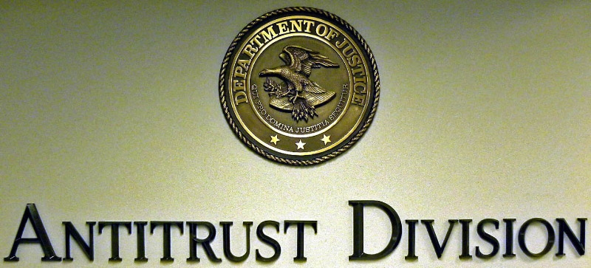

b. Strategies to Accomplish Outcomes

Prosecute International Price Fixing Cartels

Utilizing geographically dispersed field offices and one section in Washington, DC, the Antitrust Division deters private cartel behavior by investigating and challenging violations of Section 1 of the Sherman Act, including such per se (in and of themselves, clearly illegal) violations as price fixing, bid rigging, and horizontal customer and territorial allocations. Wide ranges of investigatory techniques are used to detect collusion and bid rigging, including joint investigations with the FBI and grand jury investigations. When businesses are found actively to be engaged in bid rigging, price fixing, and other market allocation schemes that negatively affect U.S. consumers and businesses (no matter where the illegal activity may be taking place), the Division pursues criminal investigations and prosecutions.

The global reach of modern cartels and their significant effects on U.S. consumers highlights the critical importance of international advocacy and coordination efforts. Increased cooperation and assistance from foreign governments continues to enhance the Division’s ability to detect and prosecute international cartel activity. In addition, the Division’s Individual and Corporate Leniency Programs, revised in recent years for greater effectiveness, have proven critical in uncovering criminal antitrust violations. Greater time and resources are devoted to investigation-related travel and translation, given the increasingly international operating environment of the criminal conspiracies being encountered. In all instances, if the Division ultimately detects market collusion and successfully prosecutes, the Division may obtain criminal fines and injunctive relief.
Civil Enforcement

The Division’s Civil strategy is comprised of two key activities - Merger Review and Civil Non-Merger work. Six Washington, DC sections and two field offices participate in the Division’s civil work. This activity serves to maintain the competitive structure of the national economy through investigation and litigation of instances in which monopoly power is sought, attained, or maintained through anticompetitive conduct and by seeking injunctive relief against mergers and acquisitions that may tend substantially to lessen competition.

Section 7 of the Clayton Act, as amended by the Hart-Scott-Rodino Antitrust Improvements Act of 1976 (HSR), requires certain enterprises that plan to merge or to enter into acquisition transactions to notify the Antitrust Division and the Federal Trade Commission (FTC) of their intention and to submit certain information. These HSR premerger notifications provide advance notice of potentially anticompetitive transactions and allow the Division to identify and block such transactions before they are consummated. HSR premerger reviews are conducted under statutorily mandated time frames. This workload is not discretionary; it results from the number of premerger filings we receive.

The number of merger transactions reviewed includes all HSR filings the Division receives and, also, reviews of proposed or consummated mergers that are below HSR filing thresholds but which present possible anti-competitive issues. HSR and non-HSR transactions may be investigated and prosecuted under Section 7 of the Clayton Act, or under Sections 1 and 2 of the Sherman Act. Referrals for non-HSR matters come from both outside the Division, via competitors or consumers, and from within the Division, based on staff knowledge of industries and information about current events.

Bank merger applications, brought to the Division’s attention statutorily via the Bank Merger Act, the Bank Holding Company Act, the Home Owners Loan Act, and the Bridge Bank Section of the Federal Deposit Insurance Act, are reviewed through a somewhat different process.

The majority of the Division’s Civil Non-Merger work is performed by four litigating sections in Washington, DC, although other Washington sections and some field offices provide support as necessary. Our Civil Non-Merger activities pick up, to some degree, where the Antitrust Division’s Criminal strategy leaves off, pursuing matters under Section 1 of the Sherman Act in instances in which the allegedly illegal behavior falls outside bid rigging, price fixing, and market allocation schemes, the areas traditionally covered by criminal prosecutory processes. Other behavior, such as group boycotts or exclusive dealing arrangements, that constitutes a "...contract, combination in the form of trust or otherwise, or conspiracy, in restraint of trade or commerce..." is also illegal under Section 1 of the Sherman Act. It is typically prosecuted through the Division’s Civil Non-Merger Enforcement Strategy.
A distinction between the Criminal and Civil Non-Merger activities is that conduct prosecuted through the Criminal strategy is considered a per se violation of the law, whereas conduct reviewed under the Civil Non-Merger activity may constitute a per se violation of the law or may be brought using a rule-of-reason analysis. Per se violations are violations considered so clearly anticompetitive that the Division must prove only that they occurred. Violations brought under a rule-of-reason analysis, on the other hand, are those that may or may not, depending on the factual situation, be illegal. In these instances, the Division must not only prove that the violation occurred, but must also demonstrate that the violation resulted in anticompetitive effects. In addition to pursuing matters under Section 1 of the Sherman Act, the Division’s Civil Non-Merger component also prosecutes violations of Section 2 of the Sherman Act, which prohibits monopolization and attempted monopolization, and Section 3 of the Clayton Act, which prohibits tying. Tying is an agreement by a party to sell one product on the condition that the buyer also purchase a different or tied product, or at least agree that he will not purchase that tied product from any other supplier. Whether addressing matters under Sections 1 or 2 of the Sherman Act or Section 3 of the Clayton Act, our Civil Non-Merger enforcement activities rely upon civil compulsory process to investigate the alleged violation.

c. Priority Goals

The Antitrust Division contributes to the FY 2012-2013 Priority Goal, “Protect the American people from financial and healthcare fraud.” In order to efficiently and effectively address financial fraud and healthcare fraud, by the end of FY 2013, increase by 5 percent over FY 2011 levels, the number of investigations completed per Department of Justice attorney working on financial fraud and healthcare fraud cases.

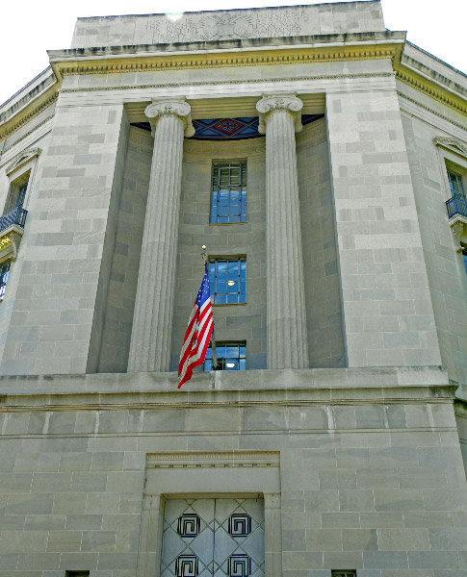

5. Exemplar - Criminal

A. Financial Fraud Enforcement

Introduction and Background

Rigorous enforcement of the Sherman Antitrust Act, which authorizes the Antitrust Division to bring criminal prosecutions against those that are involved in contracts, business combinations, and conspiracies that unreasonably restrain the nation’s free market economy, is a critical component of the Department’s overall battle against financial fraud. Indeed, in FY 2012, the Division filed 67 criminal cases and obtained over $1.1 billion in criminal fines. In these cases, we charged 16 corporations and 63 individuals, and courts imposed 45 jail terms totaling 33,603 days of jail time. These cases and the underlying investigations were brought in a range of key industries, including real estate, auto parts, and financial services, to name a few.

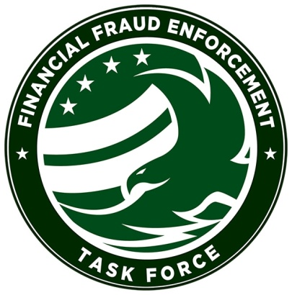
Because of the importance of criminal antitrust enforcement to the fight against financial fraud, the Antitrust Division has played, and continues to play, a prominent role in the President’s Financial Fraud Enforcement Task Force, Exec. Order No. 13519, 74 Fed. Reg. 60, 123 (Nov. 17, 2009). In particular, the Division is a key contributor to the efforts of the Task Force to detect and prosecute mortgage frauds, securities and commodities frauds, and frauds preying on funds dedicated to assist in the economic recovery pursuant to the American Recovery and Reinvestment Act.

Mortgage and Foreclosure Fraud

Since the beginning of calendar year 2011, the Antitrust Division has identified a pattern of collusive schemes among real estate speculators aimed at eliminating competition at real estate foreclosure auctions around the country. Instead of competitively bidding at public auctions for foreclosed properties, groups of real estate speculators work together to keep prices at public foreclosure auctions artificially low by paying each other to refrain from bidding or holding unofficial “knockoff” auctions among themselves. While the country continues to face unprecedented home foreclosure rates, the collusion taking place at public auctions on the steps of courthouses and municipal buildings around the country is artificially driving down foreclosed home prices and enriching the colluding real estate speculators at the expense of homeowners, municipalities and lending institutions. The impact of these collusive schemes is far-reaching because they negatively affect home prices in the neighborhoods where the foreclosed properties are located. Similar collusive conduct has also been detected among bidders for public tax liens.
To combat this anticompetitive epidemic, the Antitrust Division, in conjunction with the FBI, developed a Real Estate Foreclosure Initiative. The Initiative includes outreach and training efforts designed to raise awareness of the investigative community and public about bid rigging and fraud at real estate foreclosure and tax lien auctions. The Initiative also includes information sharing and coordinated enforcement efforts with our law enforcement partners meant to facilitate the identification, investigation, and prosecution of bid-rigging and collusive conduct at public auctions.

As of January 2013, as a result of the Division’s efforts, 59 defendants have pleaded guilty to real estate foreclosure and tax liens conspiracies across the United States that suppress and restrain competition in ways that harm our communities and already-financially distressed homeowners. The Division is coordinating its Initiative through the Mortgage Fraud Working Group of the Financial Fraud Enforcement Task Force.

Securities and Commodities Fraud

The Antitrust Division has also been integral to the Department’s efforts to combat securities, commodities, and corporate and investment frauds. These so called “Wall Street” frauds are at the root of many of the problems that have plagued the nation’s markets, businesses and consumers, and continue to act as a drag on the nation’s ability to sustain a full economic recovery.

Of particular note, during the past year, the Division, along with other federal agencies, has been investigating criminal conspiracies involving bid-rigging in the municipal bond investments market. The schemes under investigation involve unlawful agreements to manipulate the bidding process on municipal investment and related contracts – financial instruments which were used to invest the proceeds of, or manage the risks associated with, bond issuances by municipalities and other public entities. Critical municipal infrastructure, like roads, schools, and other projects, are supported by the bonds affected by these crimes.

As of January 2013, the Division’s ongoing investigation has resulted in criminal charges against 20 former executives of various financial services companies and one corporation. Nineteen of the 20 executives charged have pleaded guilty or were convicted at trial. The remaining executive awaits trial.

The investigation has also produced numerous resolutions with large financial institutions implicated in the schemes, including JPMorgan Chase, UBS AG, Wachovia Bank N.A., Bank of America, and GE Funding Capital Market Services, Inc. These financial institutions have agreed to pay a combined total of nearly $750 million in restitution, penalties and disgorgement to federal and state agencies for their roles in the conduct.

The Division is coordinating its municipal bonds investigation and other efforts in the financial services industries with other members of the Securities, Commodities and Investment Fraud Working Group of the Financial Fraud Enforcement Task Force.

Economic Recovery Fraud

With the passage of the American Recovery and Reinvestment Act of 2009, signed by President Obama in February 2009, the Division’s role to uphold the American public’s expectation that our nation’s $787 billion investment in economic recovery will not fall victim to fraud and other illegal activity was clearly evident. Accordingly, within one month of the Recovery Act becoming Public Law, the Antitrust Division launched an “Economic Recovery Initiative” to assist in ensuring successful results from implementation of the Recovery Act.
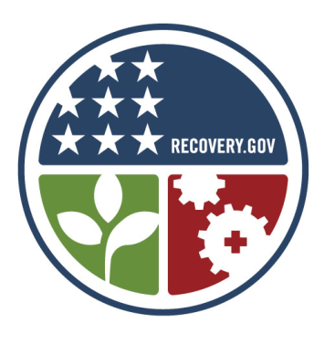
The Economic Recovery Initiative represents the Antitrust Division’s commitment to assist federal, state, and local agencies receiving Recovery Act funds to ensure that measures are in place to protect procurement and program funding processes from bid-rigging and other fraudulent conduct, as well as to ensure that those who seek to corrupt the competitive bidding process are prosecuted to the fullest extent of the law. A principal aim of the Initiative is training government officials to prevent, detect, and report efforts by parties to unlawfully profit from stimulus awards before those awards are made and taxpayer money is wasted. This focus reflects the Antitrust Division’s experience from investigating and prosecuting fraud that the potential risk of collusion and fraud relating to lucrative government contracts is dramatically minimized when an early and strong emphasis is placed on prevention and detection. Another cornerstone of the Initiative is promoting holistic enforcement of Recovery Act frauds – that is, ensuring that enforcement in this area not be limited to merely criminal and/or civil prosecution, but also includes potential administrative action and suspension and debarment measures.

The Division’s Initiative remains a central part of the efforts of the Recovery Act Fraud Working Group of the Financial Fraud Enforcement Task Force. The Task Force’s Recovery Act Fraud Working Group, which is co-chaired by the Assistant Attorney General for the Antitrust Division, is responsible for coordinating a national strategy to draw on all the resources and expertise of the Department, as well as other partner agencies, regulatory authorities, and Inspectors General throughout the Executive Branch, to ensure that taxpayer funds are safeguarded from fraud and abuse and that the Recovery Act effort is conducted in an open, competitive, and non-discriminatory manner.

B. Automobile Parts Investigation

Introduction

In an investigation spanning three continents and involving the Federal Bureau of Investigation (FBI), the European Union, Canada’s Competition Bureau and the Japanese Fair Trade Commission, the Antitrust Division is looking into the alleged illegal business practices of major automobile parts suppliers. Initially, the investigation centered primarily on wire harnesses used in auto bodies and related products but has since expanded into other automobile parts. This investigation and the resulting penalties impact American automobile manufacturing companies and many foreign producers.

The automobile parts investigation is the largest criminal investigation the Antitrust Division has ever pursued, both in terms of its scope and the potential volume of commerce affected by the alleged illegal conduct. The ongoing cartel investigation of price-fixing and bid-rigging in the automobile parts industry has yielded charges against nine companies and twelve individuals and over $800 million in criminal fines in the investigation thus far. Two of the executives charged have agreed to serve two years in prison—the longest prison terms imposed on foreign nationals voluntarily submitting to U.S. jurisdiction for an antitrust violation.

Background and Investigation

Wire harnesses are the distribution system of cables and connectors that carry electronic information through the car. The harnesses are generally considered to be the ‘central nervous system’ of a car, linking the car’s computers to the various relevant functions in the vehicle. The list of products involved in the Division’s investigation has expanded from wire harnesses to include instrument panel clusters, fuel senders, electronic control units, heater control panels, speed sensor wire assemblies, seatbelts, airbags, and steering wheels.

The Antitrust Division is investigating whether the auto parts companies that provide component parts to vehicle manufacturers such as Honda and Toyota participated in illegal anti-competitive cartel conduct, with some suspected activity dating back to 2000. Specific charges to date include price-fixing and bid-rigging conspiracies.

In some cases, conspirators that have plead guilty to-date carried out the conspiracies by agreeing during meetings and conversations to allocate the supply of the automobile products on a model-by-model basis and to coordinate price adjustments requested by automobile manufacturers in the United States and elsewhere. They sold the auto parts to manufacturers at non-competitive, rigged and fixed prices and monitored the prices to make sure those involved in the conspiracies adhered to the agreed upon bid-rigging and price-fixing schemes.

Results

The following corporate fines and jail sentences have been agreed to by the defendants in the auto parts investigation since the beginning of FY 2011:

Yazaki Corporation | - $470 million—the second largest criminal fine ever for an antitrust violation  - wire harnesses and related products, instrument panel clusters, fuel senders  - 6 executives ranging from 14 months to 2 years
Furukawa Electric Company Ltd. | - $200 million  - wire harnesses and related products  - 3 executives ranging from one year and one day to 18 months
DENSO Corporation | - $78 million  - electronic control units and heater control panels  - 2 executives ranging from one year and one day to 14 months
Fujikura Ltd | - $20 million  - wire harnesses and related products
Tokai Rika Co. Ltd. | - $17.7 million  - interior temperature controls
Autoliv, Inc. | - $14.5 million  - seatbelts, airbags, steering wheels
TRW Deutschland Holding GmbH | - $5.1 million  - seatbelts, airbags, steering wheels
G.S. Electech Inc. | - $2.75 million  - speed sensor wire assemblies
Nippon Seiki Co. Ltd. | - $1 million – instrument panel clusters
Unnamed Company (Company ‘A’) | - 1 executive for one year  - anti-vibration rubber parts

Conclusion

The criminal activity associated with the automobile parts investigation had a significant impact on automotive manufacturers in the United States, some of which had been occurring for at least a decade. The conduct also potentially affected commerce on a global scale in other markets where automobiles are manufactured and/or sold.

Criminal antitrust enforcement remains a top priority of the Antitrust Division. The automobile parts investigation continues and additional fines and jail sentences are expected to follow. The importance of rooting out this type of illegal criminal conduct cannot be overstated as it negatively impacts the United States economy and results in higher prices for consumers and businesses.

6. Exemplars – Civil

A. AT&T, Inc. / T-Mobile USA, Inc.

Introduction

In March 2011, AT&T Inc. announced an agreement to purchase T-Mobile USA, Inc. from Deutsche Telekom AG (DT) for $39 billion – a transaction that would combine the second and fourth-largest U.S. mobile wireless carriers. Mobile wireless telecommunications services are critically important, with more than 300 million mobile wireless devices in use today in the United States. The industry generates more than $160 billion in annual U.S. revenues. Mobile wireless services include both voice and data provided to a variety of devices including, for example, feature phones, smart phones, data cards, tablets, and e-readers.

Background and Investigation

In August 2011, following an extensive investigation, the Division sued on behalf of the United States to block the transaction. Subsequently, seven states joined as plaintiff including New York, Washington, California, Illinois, Massachusetts, Ohio, and Pennsylvania -- and the Commonwealth of Puerto Rico.

The Division alleged the transaction would eliminate one of only four nationwide facilities-based mobile wireless telecommunications carriers, lessening competition across the United States for mobile wireless telecommunications services – including in 97 of the top 100 local markets. The four nationwide wireless providers account for more than 90 percent of mobile wireless connections. The Division’s investigation focused on the following harmful effects if the merger were allowed to proceed:

- As a significant number of customers tended to switch between AT&T and T- Mobile, the merger would cause a significant loss of head-to-head competition.

- Because T-Mobile was a price leader and an innovative competitor (for instance, being the first carrier to roll out 4G HSPA+ technology nationwide), the merger likely would have resulted in a loss of significant product variety and innovation.

- The reduction in the number of nationwide competitors from four to three likely would have increased the risk of coordinated interaction between carriers, particularly since T-Mobile was–and likely would continue to be–a disruptive influence on the marketplace.
- The merger would have reduced competition nationally for mobile wireless telecommunications services sold to enterprise and government customers. These customers tended to purchase services differently from individual consumers, have somewhat different needs, and rarely considered a non-nationwide or non-facilities-based provider.

Although the defendants argued that the transaction would generate substantial efficiencies, the magnitude of those efficiencies was greatly overstated and could generally be achieved by other less anticompetitive means.

Conclusion

Trial was set for February 2012. Substantial discovery ensued and included:

- Over one million documents produced by the defendants (in addition to the nearly two million produced during the investigation)

- Over 100 third parties served with subpoenas

- The response by both the Division and defendants to numerous interrogatories (i.e. formal, written questions asked by the opposing side)

- The exchange of initial witness lists, and the identification of 20 experts as potential testifiers

In the face of the Department’s lawsuit, as well as concerns about the merger expressed by the Federal Communications Commission (FCC), the parties announced their abandonment of the transaction in December 2011. Had this merger been allowed to proceed, the harm to American consumers would likely have been billions of dollars a year in higher prices, as well as reduced choice and less innovation.

B. H&R Block, Inc. / 2SS Holdings, Inc. (TaxACT)

Introduction

In May 2011, the Department filed an antitrust lawsuit in the U.S. District Court for the District of Columbia seeking to block H&R Block, Inc.’s proposed acquisition of 2SS Holdings, Inc., the makers of the TaxACT digital do-it-yourself (“DDIY”) tax preparation products. The Department alleged that H&R Block’s acquisition of 2SS would substantially lessen competition in the market for DDIY tax preparation products by combining the second- and third-largest providers in this market.

Background and Investigation

DDIY tax preparation products allow U.S. taxpayers to file their individual tax returns without the difficulties of filling out tax forms by hand, and at a significantly lower cost than hiring a tax professional. With the help of a simple interview process performed through a computer, these products allow taxpayers to provide their personal and financial information, receive completed tax forms, and file their tax returns over the internet or by mail. DDIY tax preparation products are accessible by three different means: online through an internet browser, software installed on a personal computer and downloaded from the internet, and software installed on a personal computer from a disc. These products are used by a significant number of American taxpayers. Out of approximately 140 million Americans who filed individual tax returns in 2010, approximately 35 to 40 million of those taxpayers relied on DDIY products.

The DDIY tax preparation market is highly concentrated. As of tax season 2010, the three largest firms—Intuit (makers of TurboTax), H&R Block, and 2SS—collectively held a 90% share of this market. H&R Block’s acquisition of 2SS would have put that 90% share in the hands of two companies, potentially resulting in price increases for DDIY products of over 12%, and eliminating 2SS, which has been a particularly aggressive and innovative competitor. Over the past several years, 2SS has repeatedly forced the industry to offer taxpayers lower-priced and higher-quality DDIY products. The best example of 2SS’s leadership in the industry is the fact that it was the first company to offer consumers the ability to electronically file their federal individual tax returns for free. By allowing H&R Block to acquire 2SS, this dynamic and competitive force in the industry would have been eliminated, and American taxpayers would have lost the significant benefits of this competition.

Conclusion

The Department proceeded to trial in September 2011, and in October 2011 the court permanently blocked the acquisition. In an 86-page opinion, the court granted the Department’s motion for a permanent injunction and concluded that “anticompetitive effects are a likely result of the merger . . . .” As a result, 2SS will remain an option for American taxpayers looking to prepare their tax returns with a DDIY product, and taxpayers will continue to enjoy the benefits that 2SS offers as a competitive force in the DDIY market.

C. Non-Merger: American Express, MasterCard, and Visa: Credit Card Merchant Restraints

Introduction

In 2009, consumers used credit and charge cards issued by American Express, MasterCard, and Visa to make more than $1.7 trillion in purchases. Merchants paid these three companies an estimated $35 billion in acceptance costs or ‘swipe fees’. A swipe fee is paid every time a credit card is used and merchants must agree to certain rules, or restraints, in order to accept the cards for payment of purchases.
In October 2010, the Antitrust Division and seven states (Connecticut, Iowa, Maryland, Michigan, Missouri, Ohio, and Texas) filed a complaint against American Express, MasterCard, and Visa (the defendants) to prevent them from imposing on merchants certain restraints that insulate the defendants from competition in violation of the Sherman Act.

Background and Investigation

The three defendants provide network services for general purpose credit and charge cards. They operate the infrastructure necessary to authorize, settle, and clear payments made with their cards. Millions of merchants around the United States that accept these cards are consumers of network services.

According to the complaint, American Express, MasterCard and Visa maintained rules that prohibited merchants from encouraging consumers to use lower-cost payment methods when making purchases. For example, the rules prohibited merchants from offering discounts or other incentives to consumers in order to encourage them to pay with credit cards that cost the merchant less to accept. Ultimately, these rules result in consumers paying more for their purchases and increase merchants’ costs of doing business.

These restraints allow the defendants to maintain high prices for network services with confidence that no competitor will take away significant transaction volume through competition in the form of merchant discounts or benefits to customers that use lower cost payment options. The defendants’ prices for network services to merchants are therefore higher than they would be without the restraints. Because the restraints result in higher merchant costs, and merchants pass these costs on to consumers, retail prices are higher generally for consumers.

Conclusion

Shortly after filing the complaint, the Division reached a final judgment agreement with Visa and MasterCard. Defendant American Express was not a party to the settlement, and the litigation against it is continuing. The final judgment generally prohibits Visa and MasterCard from enforcing any rule or agreement that prevents merchants from offering customers a discount for using a particular card for payment, expressing a preference for the use of a particular card, promoting a particular card, or communicating to customers the estimated costs incurred by the merchant when a customer pays with a particular card.

In July 2011, the Court agreed to the final judgment, agreeing that the Division had demonstrated that “the Proposed Final Judgment furthers the public interest by removing the anticompetitive impact of Visa’s and MasterCard’s anti-steering rules . . . .”

V. Program Changes by Item

Item Name: Position/FTE Adjustment

Budget Decision Unit(s): Antitrust

Strategic Goal(s) & Objective(s): Strategic Goal II: Prevent Crime, Protect the Rights of the American People and Enforce Federal Law.

Strategic Objective 2.6: Protect the federal fisc and defend the interests of the United States

Organizational Program: Antitrust Division’s Enforcement Programs

Component Ranking of Item: 1

Program Reduction: Positions -50 Atty -10 FTE 0 Dollars $0

Description of Item

As part of the Department’s evaluation of processes to find the most efficient management of resources, this program change realigns FTP numbers with current staffing levels.

Impact on Performance

The impact on performance for this program change is minimal as it removes only authorized positions that the Antitrust Division is not currently able to fund. With this change, the Division expects to meet all performance goals and enforce its mission. In addition, the Division expects to fully comply with all legally mandated requirements and deadlines.

VI. Exhibits

United States Department of Commerce, Bureau of Economic Analysis, AU.S. International Trade in Goods and Services@, http://www.bea.gov/newsreleases/international/trade/2012/pdf/trad1012.pdf, December 2012.
2 Connor, John M. “Statistics on Modern Private International Cartels, 1990-2005”, The American Antitrust Institute - Working Paper 07-01, January 10, 2007.
3 Anupreeta Das, Dana Cimilluca. “Same Old, Same Old in the Mergers Arena”, The Wall Street Journal, January 2, 2013, p. R19.
4 Farrell, Maureen. “M&A Making a Comeback” www.cnnmoney.com, February 14, 2013, retrieved February 25, 2013. http://money.cnn.com/2013/02/12/investing/merger-acquisition/index.html
5 CTIA – “Wireless Quick Facts” www.ctia.org, November 2012, retrieved February 25, 2013. http://www.ctia.org/consumer_info/service/index.cfm/AID/10323
6 Smith, Aaron. "17% of cell phone owners do most of their online browsing on their phone, rather than a computer or other device" Pew Internet & American Life Project, June 26, 2012, retrieved February 25, 2013. http://www.pewinternet.org/~/media//Files/Reports/2012/PIP_Cell_Phone_Internet_Access.pdf
7 Rainie, Lee. “24% of internet users have made phone calls online’’, Pew Internet and American Life Project, May 30, 2011, retrieved January 19, 2012 http://pewinternet.org/Reports/2011/13--Internet-phone-calls--Skype.aspx
8 “The Budget and Economic Outlook: Fiscal Years 2013 to 2023.” Congressional Budget Office, February 2013, p.35, http://cbo.gov/sites/default/files/cbofiles/attachments/43907-BudgetOutlook.pdf

